**Final Report for Kingdomino: Team Domino Dynasty**

University of Maryland Global Campus

UMGC CMSC 495 6380 Capstone in Computer Science (2238)

Alan Anderson, William Feighner, Michael Wood Jr., Ibadet Mijit, Jenna Seipel, & Joseph Lewis

Professor Shanna Nevarez

10 October 2023



KINGDOMINO

FINAL REPORT

Table of Contents

1. OVERVIEW 1

Summary 2

Individual Contributions 2

2. PROJECT PLAN 4

Introduction 5

Purpose 5

Scope 5

Team Member Roles 6

Figure 1 – Table of Team Member Roles 6

Exclusions 6

Constraints 7

Assumptions 7

Test Plan 7

Gameplay Mechanics 7

Display 8

Functionality 8

Anomalies 8

Test Scenarios 8

Figure 2 – Table of Test Scenarios 8

Timeline 9

Figure 3 – Table of Timeline of Development 9

3. REQUIREMENTS SPECIFICATION 14

Purpose 15

Scope 15

Requirements 15

Deliverables 16

4. SYSTEM SPECIFICATIONS 17

Purpose 18

Scope 18

Minimum System Specifications 18

5. USER GUIDE 19

Getting Started 20

System Requirements 20

How to install Java 8 20

All Done! 21

Starting the Game 21

Main Menu 22

1. Play Game 22

2. How to Play 22

3. Credits 22

4. Exit 23

How to Play 23

Player Number Selection 23

1. Two Players 24

2. Three Players 24

3. Four Players 24

Player Name Entry 25

Game Play Screen 26

1. Status Info Bar 26

2. Player Board 26

3. Player Board View Buttons 27

4. Domino Selection Buttons 27

a. Domino Selection Buttons 27

b. Meeple Selection Buttons 27

5. Domino Play on Player Board 28

6. Playable Area Overlay 28

7. Current Domino Display 29

8. Playable Area Overlay 29

a. Move Up 29

b. Move Down 29

c. Move Left 29

d. Move Right 30

e. Rotate Counter-Clockwise 30

f. Rotate Clockwise 30

g. Place Domino 30

h. Discard Domino 30

9. In-Game Option Menu 31

a. Master Sound Volume 31

b. Sound FX Volume 31

c. Music Volume 31

d. Reset Game 31

e. End Game 31

f. Exit Game 31

g. Close Options 31

10. SCORE SCREEN 32

a. Player Information 32

b. Player Board 32

c. Player Score Table 33

d. Player Score Toggle Options 33

Troubleshooting 33

What if the Game Doesn’t Start? 33

Confirm that Your System is Running Java 8 33

1. Try Running the Game from the Command Prompt 34

2. Encounter a bug? 34

6. TEST PLAN & RESULTS 35

Introduction 36

Objectives 36

Scope 36

Strategy 36

Phases II & III: Functionality to be Tested 37

1. Start Screen 37

2. Main Menu Options Screen 37

3. How to Play Screen 37

4. Credits 38

5. Player Number Select Screen 38

6. Player Name Entry Screen 38

7. Game Play Screen 39

8. Score Screen 39

9. Pre-Game Back Button 40

10. Menu Button Functionality 40

11. In-Game Options Menu 40

Test Cases 41

1. Start Screen 41

2. Main Menu Options Screen 42

3. How to Play Screen 43

4. Credits Screen 44

5. Player Number Selection Screen 45

6. Player Name Entry Screen 47

7. Game Play Screen 48

8. Score Screen 53

9. Pre-Game Back Button 55

10. Menu Button Functionality 56

11. In-Game Option Menu 57

Phase I: Functionality to be Tested 59

1. Title 59

2. Player Name Menu 59

3. Player Name Menu 59

4. Domino Selection Menu 59

5. Domino Placement Menu 59

6. Game End 60

Test Cases 61

1. Title 61

2. Player Number Menu 62

3. Player Name Menu 63

4. Domino Selection Menu 65

5. Domino Placement Menu 67

6. End Game 70

7. DESIGN & ALTERNATE DESIGNS 71

Introduction 72

Purpose 72

Scope 72

Overall Design Approach 73

Phase 1: Base Framework Design 73

Summary 73

Domino.java 73

Figure 1 – Domino.java class design 74

Figure 2 – Representation of a domino in Kingdomino 74

GameBoard.java 74

Figure 3 – GameBoard.java class design 75

Figure 4 – 9x9 Game Board Broken into 5x5 Squares at Each Edge; Point [4,4] Overlap 75

LandType.java 76

Figure 5 – LandType.java class design 76

Figure 6 – LandType.java class design 77

Player.java 78

Figure 7 – Player.java class design 78

ProjectInfo.java 78

Figure 8 – LandType.java class design 78

StaticGameDominoList.java 79

Figure 9 – StaticGameDominoList.java class design 79

TestGameBoardScoring.java 79

TextBasedKingdomino.java 79

Figure 10 – TextBasedKingdomino.java class design 80

Phase II: GUI Overlay Design 80

Summary 80

General Design Approach 81

Figure 11 – Mock Game Play GUI 81

Figure 12 – Mock Menu GUI 81

Finalizing Phase II Design Approach 82

Figure 13 – Mock Game Play GUI 82

Phase III: Beautification 83

Summary & Design Approach 83

Alternate Designs 84

8. DEVELOPMENT HISTORY 88

Summary 89

Problems Encountered 89

Phase I 90

Task List / Schedule 90

Github Learning Curve 90

Different Java Version / IDE / System Configurations 90

Phase II 91

Falling Behind Schedule 91

Java Kind of Sucks for Games 91

Managing Java Layouts 92

Phase III 92

Unexpected Bugs 92

Re-evaluation of Decisions 93

Phase I 93

Using Java 93

Building a Text-Based Foundation First 93

2D vs. 3D 94

Phase II 94

The Framework is Immutable 94

Developing a Cartoony Design Style 95

Using a UI Creator vs. Hand-Coded UI 95

How to Represent the Player’s Game Board 96

Phase III 96

Revamping the Game Design 96

Ignore Some Minor Bugs 97

Features on the Chopping Block 97

9. CONCLUSIONS 98

Lessons Learned 99

Alan Anderson 99

William Feighner 100

Michael Wood, Jr. 101

Ibadet Mijit 101

Jenna Seipel 101

Joseph Lewis 102

Design Strengths 103

Limitations 103

Suggestions for Future Improvement 104



KINGDOMINO

# 1. OVERVIEW

## Summary

Our team successfully tackled the task of creating a Kingdomino digital board game experience that plays like the original physical board game. Despite the numerous hurdles we faced, our team’s dedication and flexibility enabled us to switch focuses on a dime and reach all the milestones we set out to accomplish. As required, this final report will incorporate all of the documentation products we have developed thus far.

## Individual Contributions

|  |  |
| --- | --- |
| Alan Anderson | **Project Manager / Framework Design Team**   * Provided an abundance of the coding framework * Created background music and document design * Drafted phase reports and supplementary documents * Filled in when shortfalls developed |
| William Feighner | **Quality Control / Framework Design Team**   * Significant contributions to code creation and editing * Ensured that critical design elements were incorporated into game * Supplied some of the game graphics * Provided edits and feedback to phase reports and supplementary documents |
| Michael Wood Jr. | **Graphics Design / UI & UX Design Team**   * Major UI design contributions * Designed important UI framework systems * Supplied the awesome game graphics * Provided edits and feedback to phase reports and supplementary documents |
| Ibadet Mijit | **Testing / Documentation / Quality Control**   * MIA |
| Jenna Seipel | **Sound Design / UI & UX Design Team**   * Major sound design contributions * Assisted with overall UI design * Drafted initial test plan and user guide when Ibadet went MIA * Provided edits and feedback to phase reports and supplementary documents |
| Joseph Lewis | **Timeline Manager / UI & UX Design Team**   * Effectively managed timeline; kept us on track * Assisted with overall UI design * Conducted testing of all phases when Ibadet went MIA * Provided edits and feedback to phase reports and supplementary documents |



KINGDOMINO

# 2. PROJECT PLAN

## Introduction

Our team will create a Java-based digital board game version of the popular board game Kingdomino. The digital board game will function identically to the physical board game and contain all the same gameplay mechanics and themes. Players will select dominos each round and arrange them in a 5x5 grid, trying to score as many points as possible based on the orientation of their placed dominos. Play will continue through each round with the current player deciding, then passing control of the game to the next player in typical “pass and play” fashion. Final scores will be displayed at the end of the game.

## Purpose

The purpose of the project plan is to identify how our group intends to tackle the requirements specification and what the user expects when they use our application.

## Scope

The focus of this project will be to mimic the theme and game play of the physical board game. The game will be entirely developed in Java. Our team understands that Java game development has its own unique limitations, but we are confident that we can surpass those limitations and provide an exciting digital board gaming experience.

## Team Member Roles

### Figure 1 – Table of Team Member Roles

|  |  |
| --- | --- |
| Alan Anderson | **Project Manager / Framework Design Team**   * Oversees project and ensures it adheres to the specifications * Designs the basic framework for game logic based on board game * Implements UI into final design |
| William Feighner | **Quality Control / Framework Design Team**   * Ensures that game play experience meets quality requirement * Designs the basic framework for game logic based on board game * Implements UI into final design |
| Michael Wood Jr. | **Graphics Design / UI & UX Design Team**   * Designs 2D graphics for board game and UI implementation * Develops UI / UX for 2D implementation of game * Ensures that graphics match overall game theme |
| Ibadet Mijit | **Testing / Documentation / Quality Control**   * Tests the game at each phase ensuring there are no bugs/errors * Creates documentation (specifications, test documents, etc.) * Ensures that game play experience meets quality requirement |
| Jenna Seipel | **Sound Design / UI & UX Design Team**   * Develops sound for implementation into game * Ensures that sound matches overall game theme * Develops UI / UX for 2D implementation of game |
| Joseph Lewis | **Timeline Manager / UI & UX Design Team**   * Manages tasks and ensure team members adhere to timeline * Develops UI / UX for 2D implementation of game * Ensures that UI / UX is intuitive and easy to use |
|  |  |

## Exclusions

The game will not be playable online. Additionally, most development will be conducted through programs and platforms utilized through UMGC coursework; access to paid professional programs like Photoshop will be limited.

## Constraints

The development time is limited, with the final project due before the course ends. This will also affect our team’s ability to capitalize on the distinct levels of experience and familiarity our members have with different programming languages and development environments.

## Assumptions

It is assumed that project team members will complete the milestones outlined in the timeline on time. Additionally, it is assumed that project team members will not have access to commercial software not available through UMGC (Photoshop, etc.). Finally, it is assumed that project team members will have the necessary skills to complete their tasks and will contact the Project Manager if they need assistance.

## Test Plan

### Gameplay Mechanics

* Validate whether turn order is randomly generated at the start of the game.
* Validate whether turn order is correctly generated based on player domino selection throughout the game.
* Validate players cannot select dominos claimed by another player.
* Validate if domino placement on player game board works properly.
* Validate if player is constrained to a 5x5 game board area.
* Validate final round where there are no more dominos to draw from an empty deck.
* Validate if end game scoring is properly calculated.
* Validate if all rules for the board game Kingdomino are correctly applied.

### Display

* Validate if graphical assets are correctly generated.
* Validate if UI works properly.
* Validate if the player’s name is correctly displayed throughout the game.
* Validate if player board is correctly displayed.

### Functionality

* Validate if user can enter game through start menu.
* Validate if the user can select the number of players in the game.
* Confirm that there are no memory leaks.

### Anomalies

* Validate whether anomaly is reproducible, steps to reproduce the issue, severity of the issue, and other data needed to address it

### Test Scenarios

#### Figure 2 – Table of Test Scenarios

|  |  |
| --- | --- |
| **NUMBER OF PLAYERS** | **SCENARIO** |
| 2 Players | * User enters the number of players (2). * Each of the players enters their name. * Gameboard is initiated with 2 tabs. * Each player selects and places tiles until all tiles (24) are drawn. * The player with the most points is displayed as the winner. |
| 3 Players | * User enters the number of players (3). * Each of the players enters their name. * Gameboard is initiated with 3 tabs. * Each player selects and places tiles until all tiles (36) are drawn. * The player with the most points is displayed as the winner. |
| 4 Players | * User enters the number of players (4). * Each of the players enters their name. * Gameboard is initiated with 4 tabs. * Each player selects and places tiles until all tiles (48) are drawn. * The player with the most points is displayed as the winner. |

## Timeline

#### Figure 3 – Table of Timeline of Development

|  |  |  |  |  |
| --- | --- | --- | --- | --- |
| **KINGDOMINO: PHASE I TASKS (COURSE START TO 29 AUG)** | | | | |
| **LAYING THE GROUNDWORK BY COMPLETING THE FRAMEWORK** | | | | |
| **#** | **Task** | | **Assignee** | **Deadline** |
| **1 -** | **Create and submit project plan** | | Alan | 29-Aug |
| **1.a** |  | Draft project plan | Alan | 25-Aug |
| **1.b** |  | **Gather team input and incorporate feedback** | **EVERYONE** | **26-Aug** |
| **1.c** |  | Submit final draft to message board | Alan | 27-Aug |
| **1.d** |  | Receive professor's feedback and resubmit | Alan | 28-Aug |
| **1.e** |  | **Submit project plan to assignment folder** | **EVERYONE** | **29-Aug** |
|  |  |  |  |  |
| **2 -** | **Create timeline** | | Joseph | 26-Aug |
| **2.a** |  | Incorporate project milestones from project manager | Joseph | 26-Aug |
|  |  |  |  |  |
| **3 -** | **Create task list** | | Joseph | 26-Aug |
| **3.a.** |  | Capture milestones and assign to team members based on project manager guidance | Joseph | 26-Aug |
|  |  |  |  |  |
| **4 -** | **Begin text-based game framework** | | Framework team | 22-Aug |
| **4.a** |  | Implement gameplay logic | Framework team | 22-Aug |
| **4.b** |  | Ability to 2-4 player selection | Framework team | 22-Aug |
| **4.c** |  | Ability to name players | Framework team | 22-Aug |
| **4.d** |  | Remove number of dominos based on number of players | Framework team | 22-Aug |
| **4.e** |  | Implement modified game play rules for 2 player game | Framework team | 22-Aug |
| **4.f** |  | Ensure game board captures domino placement, land types, and crown numbers | Framework team | 22-Aug |
| **4.e** |  | Implement domino placement rules | Framework team | 22-Aug |
| **4.f** |  | Properly calculate final scores | Framework team | 22-Aug |
|  |  |  |  |  |
| **5 -** | **Begin graphic asset creation** | | Michael | 22-Aug |
| **5.a** |  | Create domino graphics | Michael | 22-Aug |
| **5.b** |  | Create logo graphics | Michael | 22-Aug |
| **5.c** |  | Create fonts | Michael | 22-Aug |
| **5.d** |  | Create starter tiles for initial castle placement | Michael | 22-Aug |
|  |  |  |  |  |
| **6 -** | **Begin sound asset creation** | | Jenna | 22-Aug |
| **6.a** |  | Create title music sample | Jenna | 22-Aug |
| **6.b** |  | Create various sounds for gameplay | Jenna | 22-Aug |
|  |  |  |  |  |
| **7 -** | **Begin testing strategy and documentation creation** | | Alan Jenna | 29-Aug |
| **7.a** |  | Start working on draft test plan | Jenna | 29-Aug |
| **7.b** |  | Start working on draft project design | Alan | 29-Aug |

|  |  |  |  |  |  |
| --- | --- | --- | --- | --- | --- |
| **KINGDOMINO: PHASE II TASKS (30 AUG TO 24 SEP)** | | | | | |
| **LAYING THE 2D GUI FOUNDATION OVER THE FRAMEWORK** | | | | | |
| **#** | **Task** | | | **Assignee** | **Deadline** |
| **I -** | **Create and submit project design** | | | Alan | 12-Sep |
| **1.a** |  | Complete draft project design | | Alan | 5-Sep |
| **1.b** |  | Gather team input and incorporate feedback | | EVERYONE | 6-Sep |
| **1.c** |  | Submit final draft to message board | | Alan | 7-Sep |
| **1.d** |  | Receive professor's feedback and resubmit | | Alan | 9-Sep |
| **1.e** |  | Submit project design to assignment folder | | EVERYONE | 12-Sep |
|  |  |  |  |  |  |
| **2 -** | **Create and submit test plan and user guide** | | | Jenna | 12-Sep |
| **2.a** |  | **Test Plan** | |  | 12-Sep |
| **2.a.1** |  |  | Complete draft test plan | Jenna | 5-Sep |
| **2.a.2** |  |  | Gather team input and incorporate feedback | EVERYONE | 6-Sep |
| **2.a.3** |  |  | Submit final draft to message board Week 3 | Alan | 7-Sep |
| **2.a.4** |  |  | Receive professor's feedback and resubmit | Alan | 9-Sep |
| **2.a.5** |  |  | Submit project design to assignment folder | EVERYONE | 12-Sep |
| **2.b** |  | **User Guide** | |  | 12-Sep |
| **2.b.1** |  |  | Complete draft user guide | Jenna | 5-Sep |
| **2.b.2** |  |  | Gather team input and incorporate feedback | EVERYONE | 6-Sep |
| **2.b.3** |  |  | Submit final draft to message board Week 3 | Alan | 7-Sep |
| **2.b.4** |  |  | Receive professor's feedback and resubmit | Alan | 9-Sep |
| **2.b.5** |  |  | Submit project design to assignment folder | EVERYONE | 12-Sep |
|  |  |  |  |  |  |
| **3 -** | **Complete text-based framework** | | | Framework team | 30-Aug |
| **3.a** |  | Clean up and comment throughout code for a polished final framework | | Framework team | 30-Aug |
| **3.b** |  | Create classes for data structures that can translate into the GUI version | | Framework team | 30-Aug |
|  |  |  |  |  |  |
| **4 -** | **Begin 2D game development** | | | Framework team | 15-Sep |
| **4.a** |  | Create of Java classes that will overlay on top of text-based framework to create 2D final product | | Framework team | 15-Sep |
| **4.b** |  | Incorporate UI team products and ideas into 2D implementation | | Framework team | 15-Sep |
| **4.c** |  | Implement sound assets | | Framework team | 15-Sep |
| **4.d** |  | Implement graphics assets | | Framework team | 15-Sep |
| **4.e** |  | Ensure UI displays correctly | | Framework team | 15-Sep |
| **4.f** |  | Correct scoring to implement tie-breaker rules | | Framework team | 15-Sep |
|  |  |  |  |  |  |
| **5 -** | **Begin UI / UX development** | | | UI / UX team | 26-Aug |
| **5.a** |  | Create player number selection UI | | UI / UX team | 26-Aug |
| **5.b** |  | Create player name input UI | | UI / UX team | 26-Aug |
| **5.c** |  | Create gameplay UI | | UI / UX team | 26-Aug |
| **5.d** |  | Create final score screen UI | | UI / UX team | 26-Aug |
| **5.e** |  | Create buttons | | UI / UX team | 26-Aug |
| **5.f** |  | Provide suggestions for UI implementations to Framework Team | | UI / UX team | 26-Aug |
|  |  |  |  |  |  |
| **6 -** | **Complete sound creation** | | | Jenna | 15-Sep |
| **6.a** |  | Create opening title screen music | | Jenna | 15-Sep |
| **6.b** |  | Create sound that fires when an option is selected | | Jenna | 15-Sep |
| **6.c** |  | Create sound for placing domino on game board | | Jenna | 15-Sep |
| **6.d** |  | Create a sound for when a domino is moved over the game board | | Jenna | 15-Sep |
| **6.e** |  | Create a sound for when a domino is discarded | | Jenna | 15-Sep |
| **6.f** |  | Create music that plays when game ends | | Jenna | 15-Sep |
| **6.e** |  | Create other sound resources as required | | Jenna | 15-Sep |
|  |  |  |  |  |  |
| **7 -** | **Complete graphics creation** | | | Michael | 15-Sep |
| **7.a** |  | Create button images for domino actions (rotate clockwise, move up, etc.) | | Michael | 15-Sep |
| **7.b** |  | Create other images as required | | Michael | 15-Sep |
|  |  |  |  |  |  |
| **8 -** | **Submit Phase 1 source** | | | Alan | 20-Sep |
| **8.a** |  | Draft response to Week 5 Discussion post | | Alan | 14-Sep |
| **8.b** |  | Gather team input and incorporate feedback | | EVERYONE | 16-Sep |
| **8.c** |  | Submit final draft to message board | | Alan | 18-Sep |
| **8.d** |  | Submit Phase 1 Source to project folder | | EVERYONE | 20-Sep |

|  |  |  |  |  |  |
| --- | --- | --- | --- | --- | --- |
| **KINGDOMINO: PHASE III TASKS (25 SEP TO 11 OCT)** | | | | | |
| **BEAUTIFICATION** | | | | | |
| **#** | **Task** | | | **Assignee** | **Deadline** |
| **I -** | **Submit Phase II Source** | | | EVERYONE | 27-Sep |
| **1.a** |  | Submit Phase II Source to UMGC assignment folder | | EVERYONE | 27-Sep |
| **1.b** |  | Submit Phase II report to UMGC message board | | Alan | 27-Sep |
|  |  |  | ` |  |  |
| **2 -** | **Submit Phase III Source** | | | EVERYONE | 4-Oct |
| **2.a** |  | Submit Phase III Source to UMGC assignment folder | | EVERYONE | 4-Oct |
| **2.b** |  | Submit Phase III report to UMGC message board | | Alan | 4-Oct |
|  |  |  |  |  |  |
| **3 -** | **Submit Final Source** | | | EVERYONE | **11-Oct** |
| **3.a** |  | Submit Final Source to UMGC assignment folder | | EVERYONE | 11-Oct |
| **3.b** |  | Submit Phase III report to UMGC message board | | Alan | 11-Oct |
| **3.c** |  | Ensure final submission meets the following parameters | | EVERYONE | 11-Oct |
| **3.c.1** |  |  | Overview - including summary of individual contributions | EVERYONE | 11-Oct |
| **3.c.2** |  |  | Project Plan | EVERYONE | 11-Oct |
| **3.c.3** |  |  | Requirements Specification | EVERYONE | 11-Oct |
| **3.c.4** |  |  | System Specification | EVERYONE | 11-Oct |
| **3.c.5** |  |  | User's Guide | EVERYONE | 11-Oct |
| **3.c.6** |  |  | Test Plan and Results | EVERYONE | 11-Oct |
| **3.c.7** |  |  | Design and Alternate designs | EVERYONE | 11-Oct |
| **3.c.8** |  |  | Development History | EVERYONE | 11-Oct |
| **3.c.9** |  |  | Conclusions including lessons learned, design strengths, limitations and suggestions for future improvement | EVERYONE | 11-Oct |
| **3.c.10** |  |  | Ensure that program meets specifications identified in the grading rubric | EVERYONE | 11-Oct |
|  |  |  |  |  |  |
| **4 -** | **Additional animations and graphics** | | |  | 9-Oct |
| **4.a** |  | Domino placement animation (smoke circle ring expanding from under domino?) | | Framework Team | 9-Oct |
| **4.b** |  | Background images for each panel so it's not just a solid color background | | Framework Team | 9-Oct |
| **4.c** |  | Add credits screen to show info of project makers | | Framework Team | 9-Oct |
| **4.b** |  | Create blurry version of domino front faces for future animation | | Michael | 9-Oct |
|  |  |  |  |  |  |
| **5 -** | **Additional functionality** | | |  | 9-Oct |
| **5.a** |  | Button to show "How to Play" on game play panel so player can refresh memory while playing game | | Framework Team | 9-Oct |
| **5.b** |  | Keyboard control? | | Framework Team | 9-Oct |



KINGDOMINO

# 3. REQUIREMENTS SPECIFICATION

## Purpose

The requirement specifications will detail what the program will do.

## Scope

This document will describe the intended functionality of the program.

## Requirements

Two to four players will be able to play this game as a typical “pass and play” digital board game, where a player concludes their turn, then physically passes control of the game to the next player. At the start of the game, players can choose the number of players that will play it, then enter the names for each of those players. The game will then remove several dominos according to the number of players: 24 dominos removed for 2 players, 12 for 3 players, and 0 for 4 players. Notably, unlike in three or four player games where each player takes one domino per turn, players in a two-player game will be able to take two dominos each per turn.

During the main portion of the game, players will select dominos each turn, then place those dominos on their player board according to these following rules: at least one domino face of the domino to be placed must be matching a domino face of the domino it will be placed next to, Dominos can only be placed in a 5x5 area around the player’s castle. The game board must automatically resize to display the play area for the player each time a new domino is placed. Players can move dominos up, down, left, and right, and rotate dominos clockwise and counterclockwise.

When all dominos in the game have run out, the end of game sequence will be triggered, and players will be able to see which player scored the most points. In the background, a recursive algorithm will run through the player’s game board, treating it as a 2D matrix. The recursive algorithm will start at the first position of the player’s game board (0,0), then check each position next to it to see whether those positions contain domino faces of the matching type, then add them to a scoring array list to be captured later and computed for the final score. A player's score is the sum of the size of each contiguous terrain multiplied by the number of crowns in the terrain. For example, a block of forest consisting of 4 tiles containing 2 crowns would count as 8 toward the player’s score.

The digital board game experience will play out the same as the physical board game experience, without all the mess of having to reshuffle and restack the dominos after each game. Players will enjoy the ambient music and sound effects while they play the game. The game will be developed fully in Java and employ simple 2D graphics and animations, thus there will be no major strain on most systems to run the program. Users will be unable to make alterations to the game.

## Deliverables

* Gameplay is identical with that of Kingdomino for 2 to 4 players.
* Graphics-based digital board game based on text-based framework.
* Intuitive GUI that is easy to use.
* Sound and music that enhance the gameplay experience.



KINGDOMINO

# 4. SYSTEM SPECIFICATIONS

## Purpose

The system specifications will describe the minimum system requirements needed to successfully run the program.

## Scope

This section will cover the minimum system requirements across multiple Operating Systems.

## Minimum System Specifications

The Kingdomino digital board game originally targeted JDK 17, but will now be designed using JDK 20. The move to JDK 20 comes with improvements to dealing with screen resolutions, antialiasing, and font scaling.

* \Windows PC: Windows 10 or higher
* Linux PC: Oracle Linux 7 or higher, or Ubuntu 14.04 LTS or higher
* macOS PC: macOS 11 or higher
* JDK Version: JDK 20
* Disk Space: 300 MB available (JDK + game)
* RAM: At least 512 MB



KINGDOMINO

# 5. USER GUIDE

## Getting Started

Before starting the game, players must ensure basic system requirements are met and the proper version of Java is installed.

### System Requirements

* 1. Windows PC: Windows 10 or higher
  2. Linux PC: Oracle Linux 7 or higher, or Ubuntu 14.04 LTS or higher
  3. macOS PC: macOS 11 or higher
  4. Java Version: Java 8

### How to install Java 8

1. Visit <https://www.java.com/download/ie_manual.jsp>
2. Installation instructions: <https://www.java.com/en/download/help/ie_online_install.html>

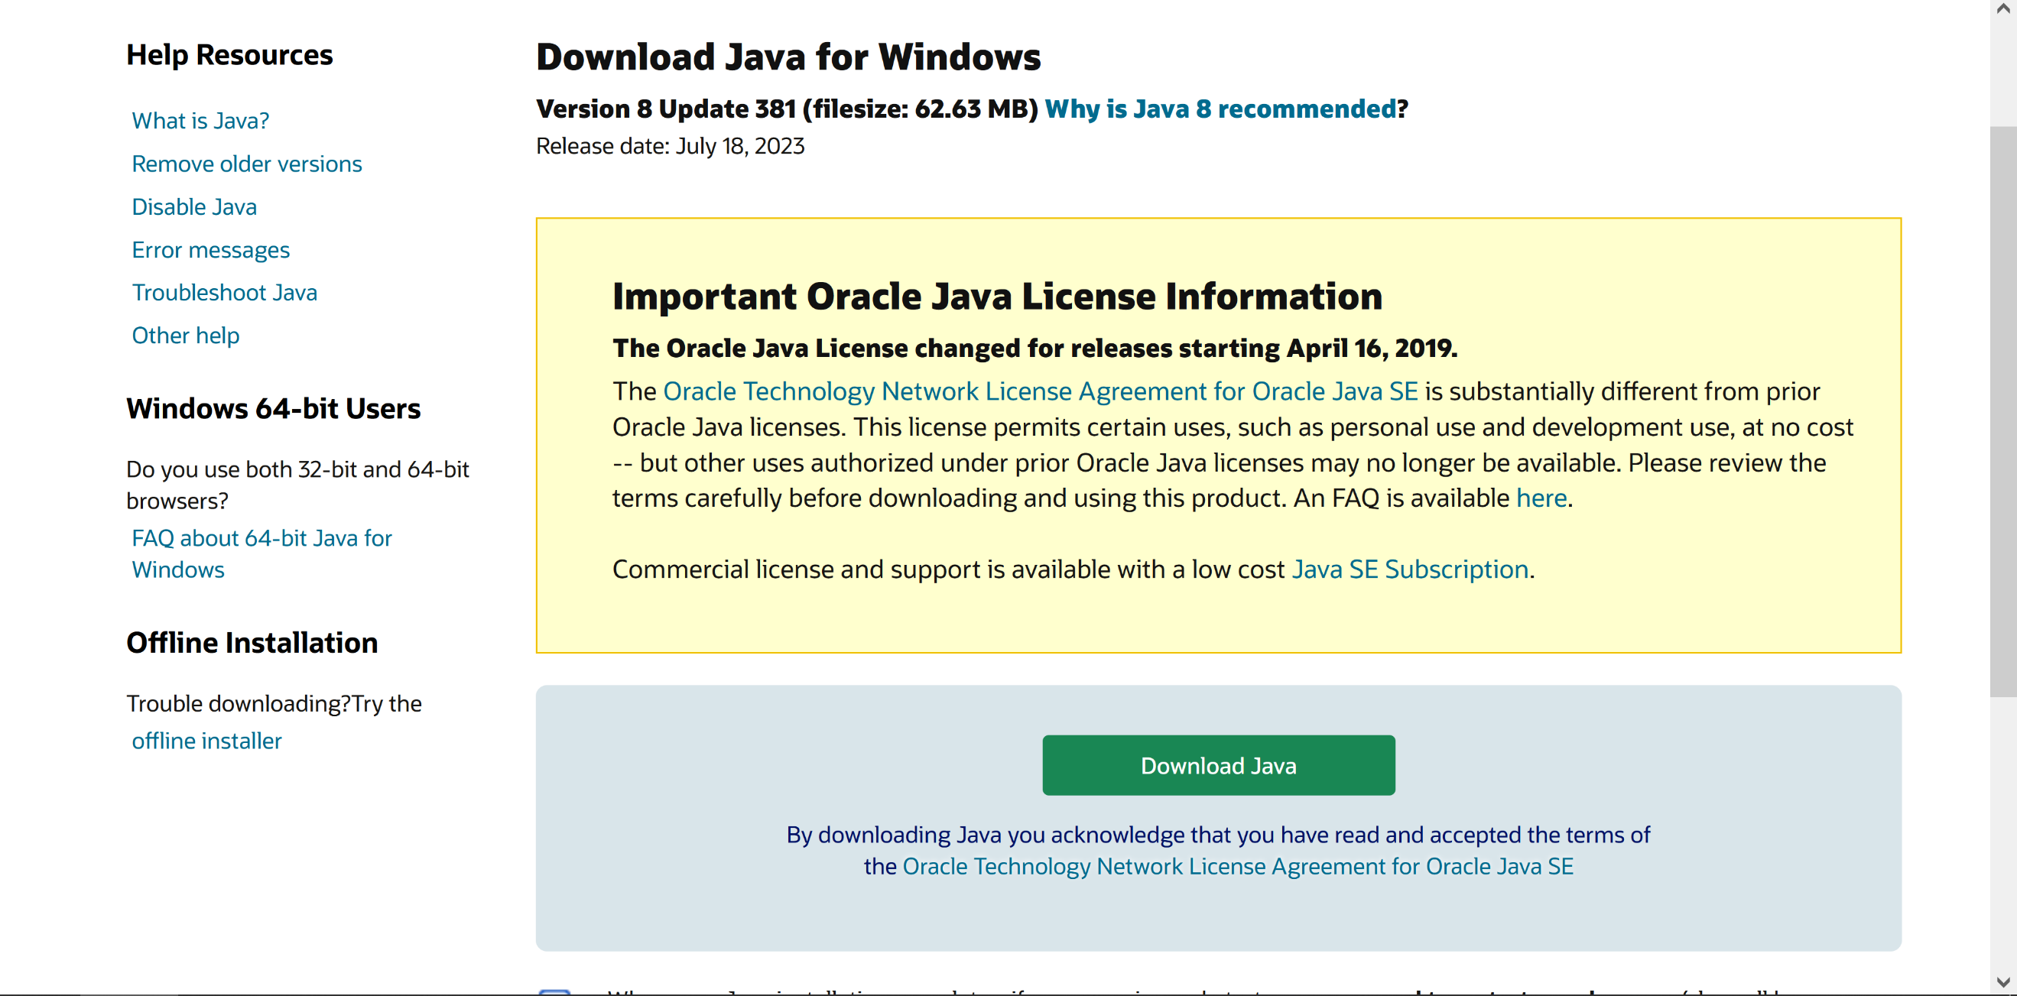

### All Done!

Once Java 8 is installed, simply double click the JAR to run the game!

## Starting the Game

Once the game has started, players are welcomed with an animated title screen. To proceed, click the “Click to Start” button.

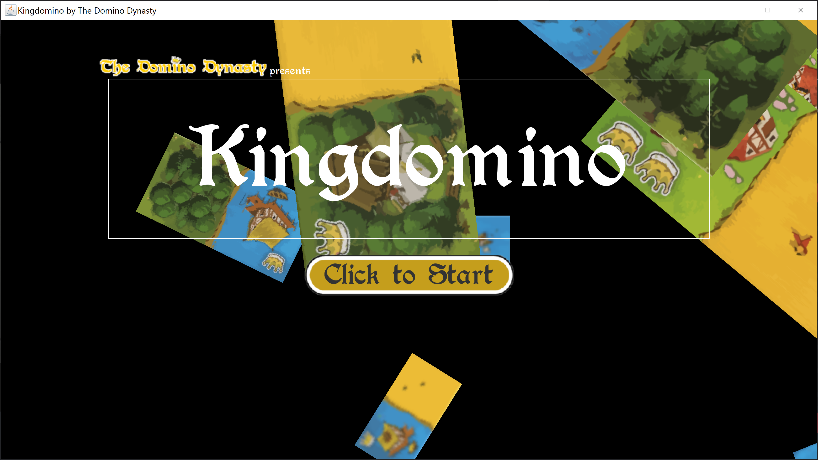

## Main Menu

Upon entering the main menu, players are greeted with three options to choose from. Additionally, there is a back button situated at the bottom right of the screen.

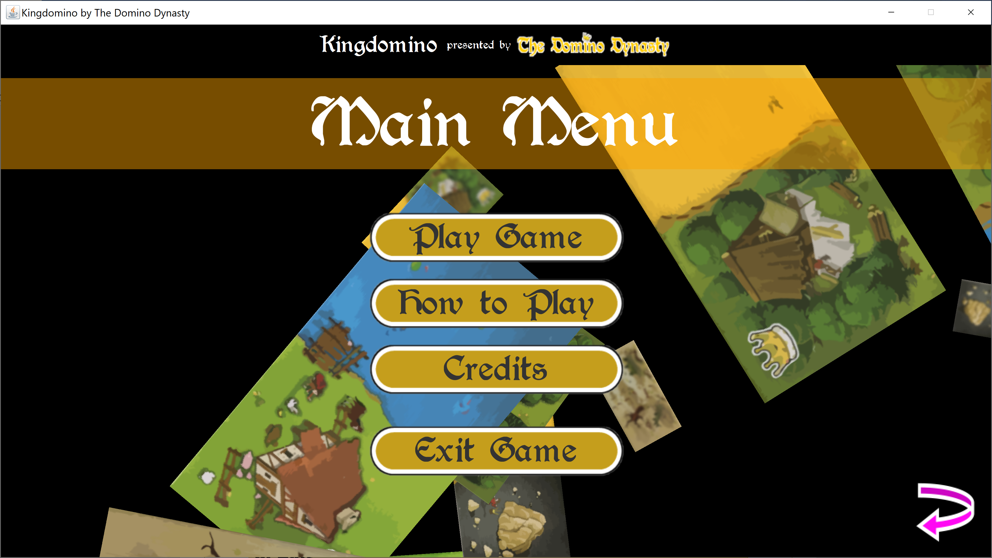

### 1. Play Game

Selecting this option players will advance to the Player Number Selection screen

### 2. How to Play

This option will display instructions on how to play the game and operate the GUI for the game play portion

### 3. Credits

Shows credits, resources, and overall information about the game.

### 4. Exit

Simply exits the game

## How to Play

This section of the game consists of text and animations showing the user the game rules and how to play the game.

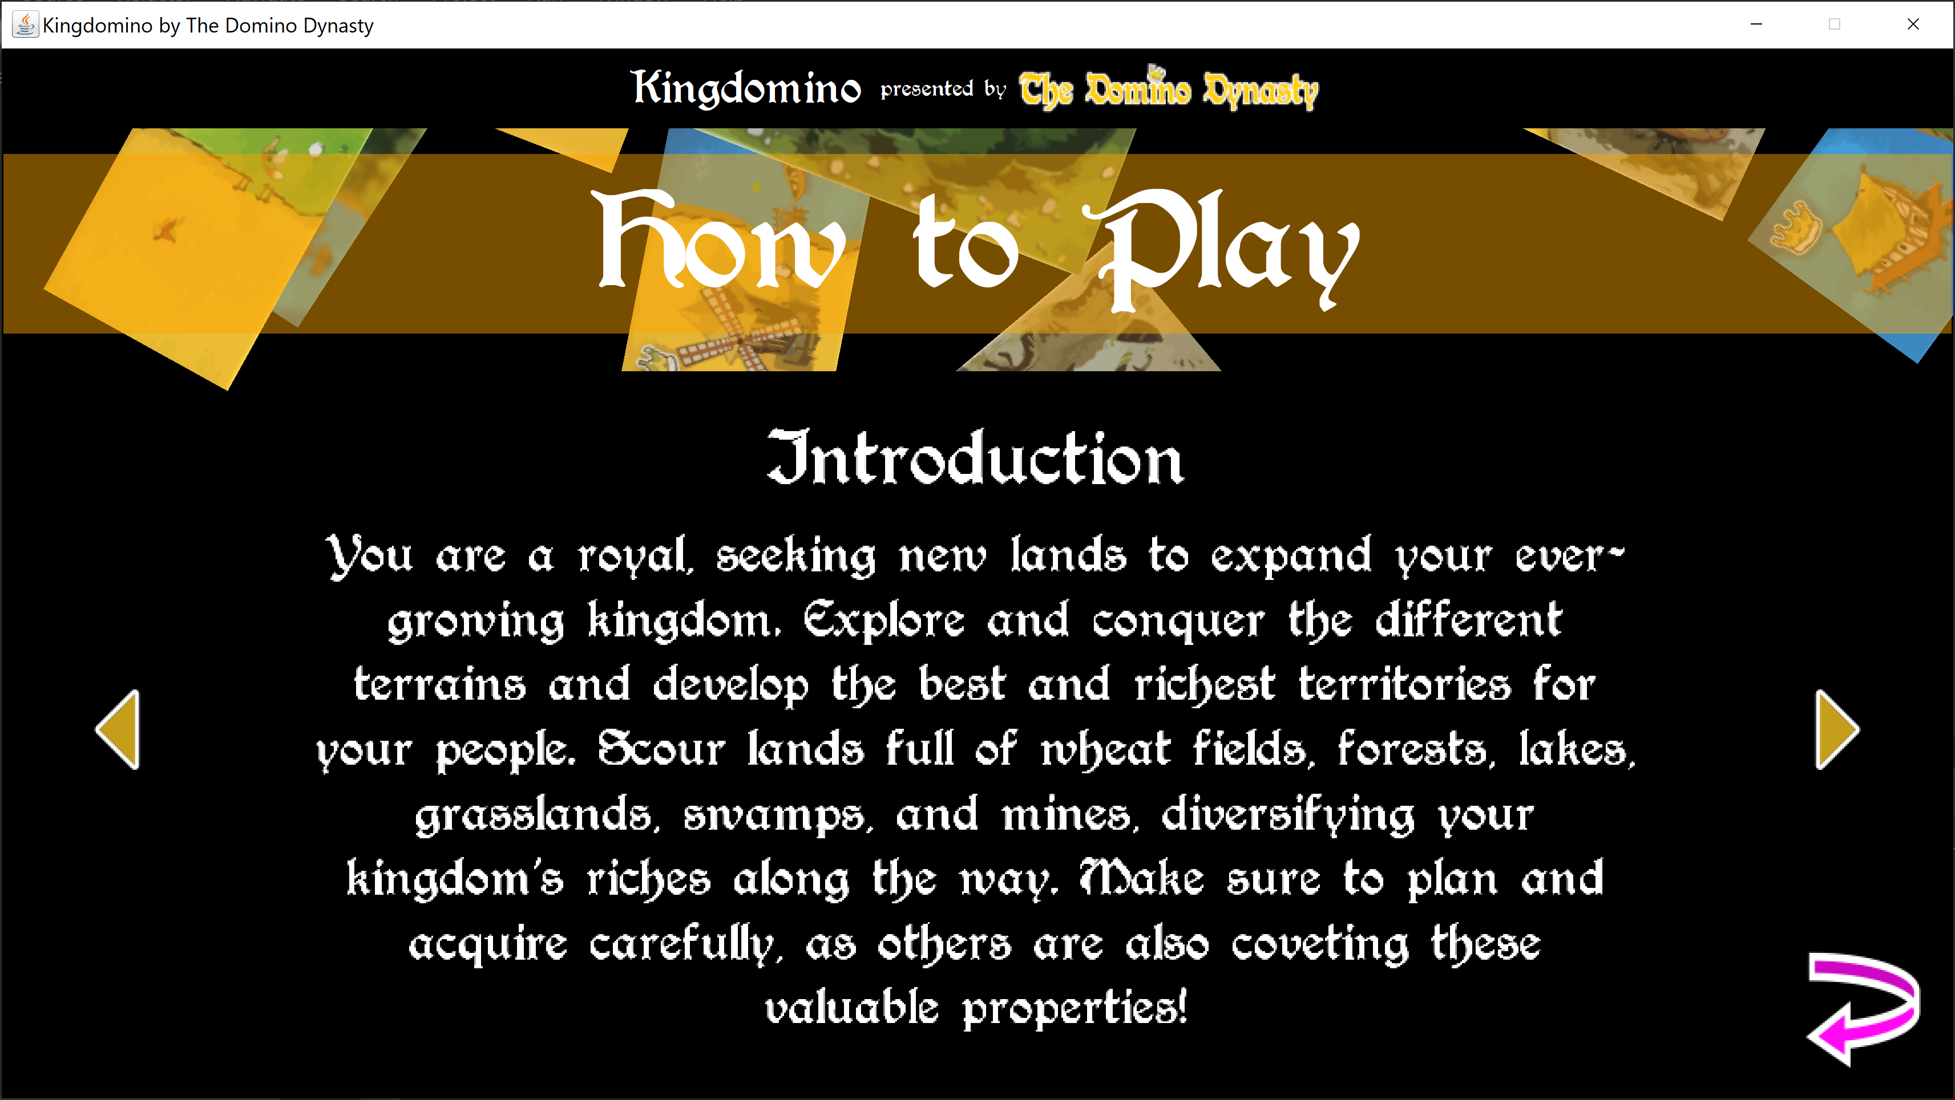

## Player Number Selection

Upon entering the player number selection, players are greeted with three multiplayer options to choose from.

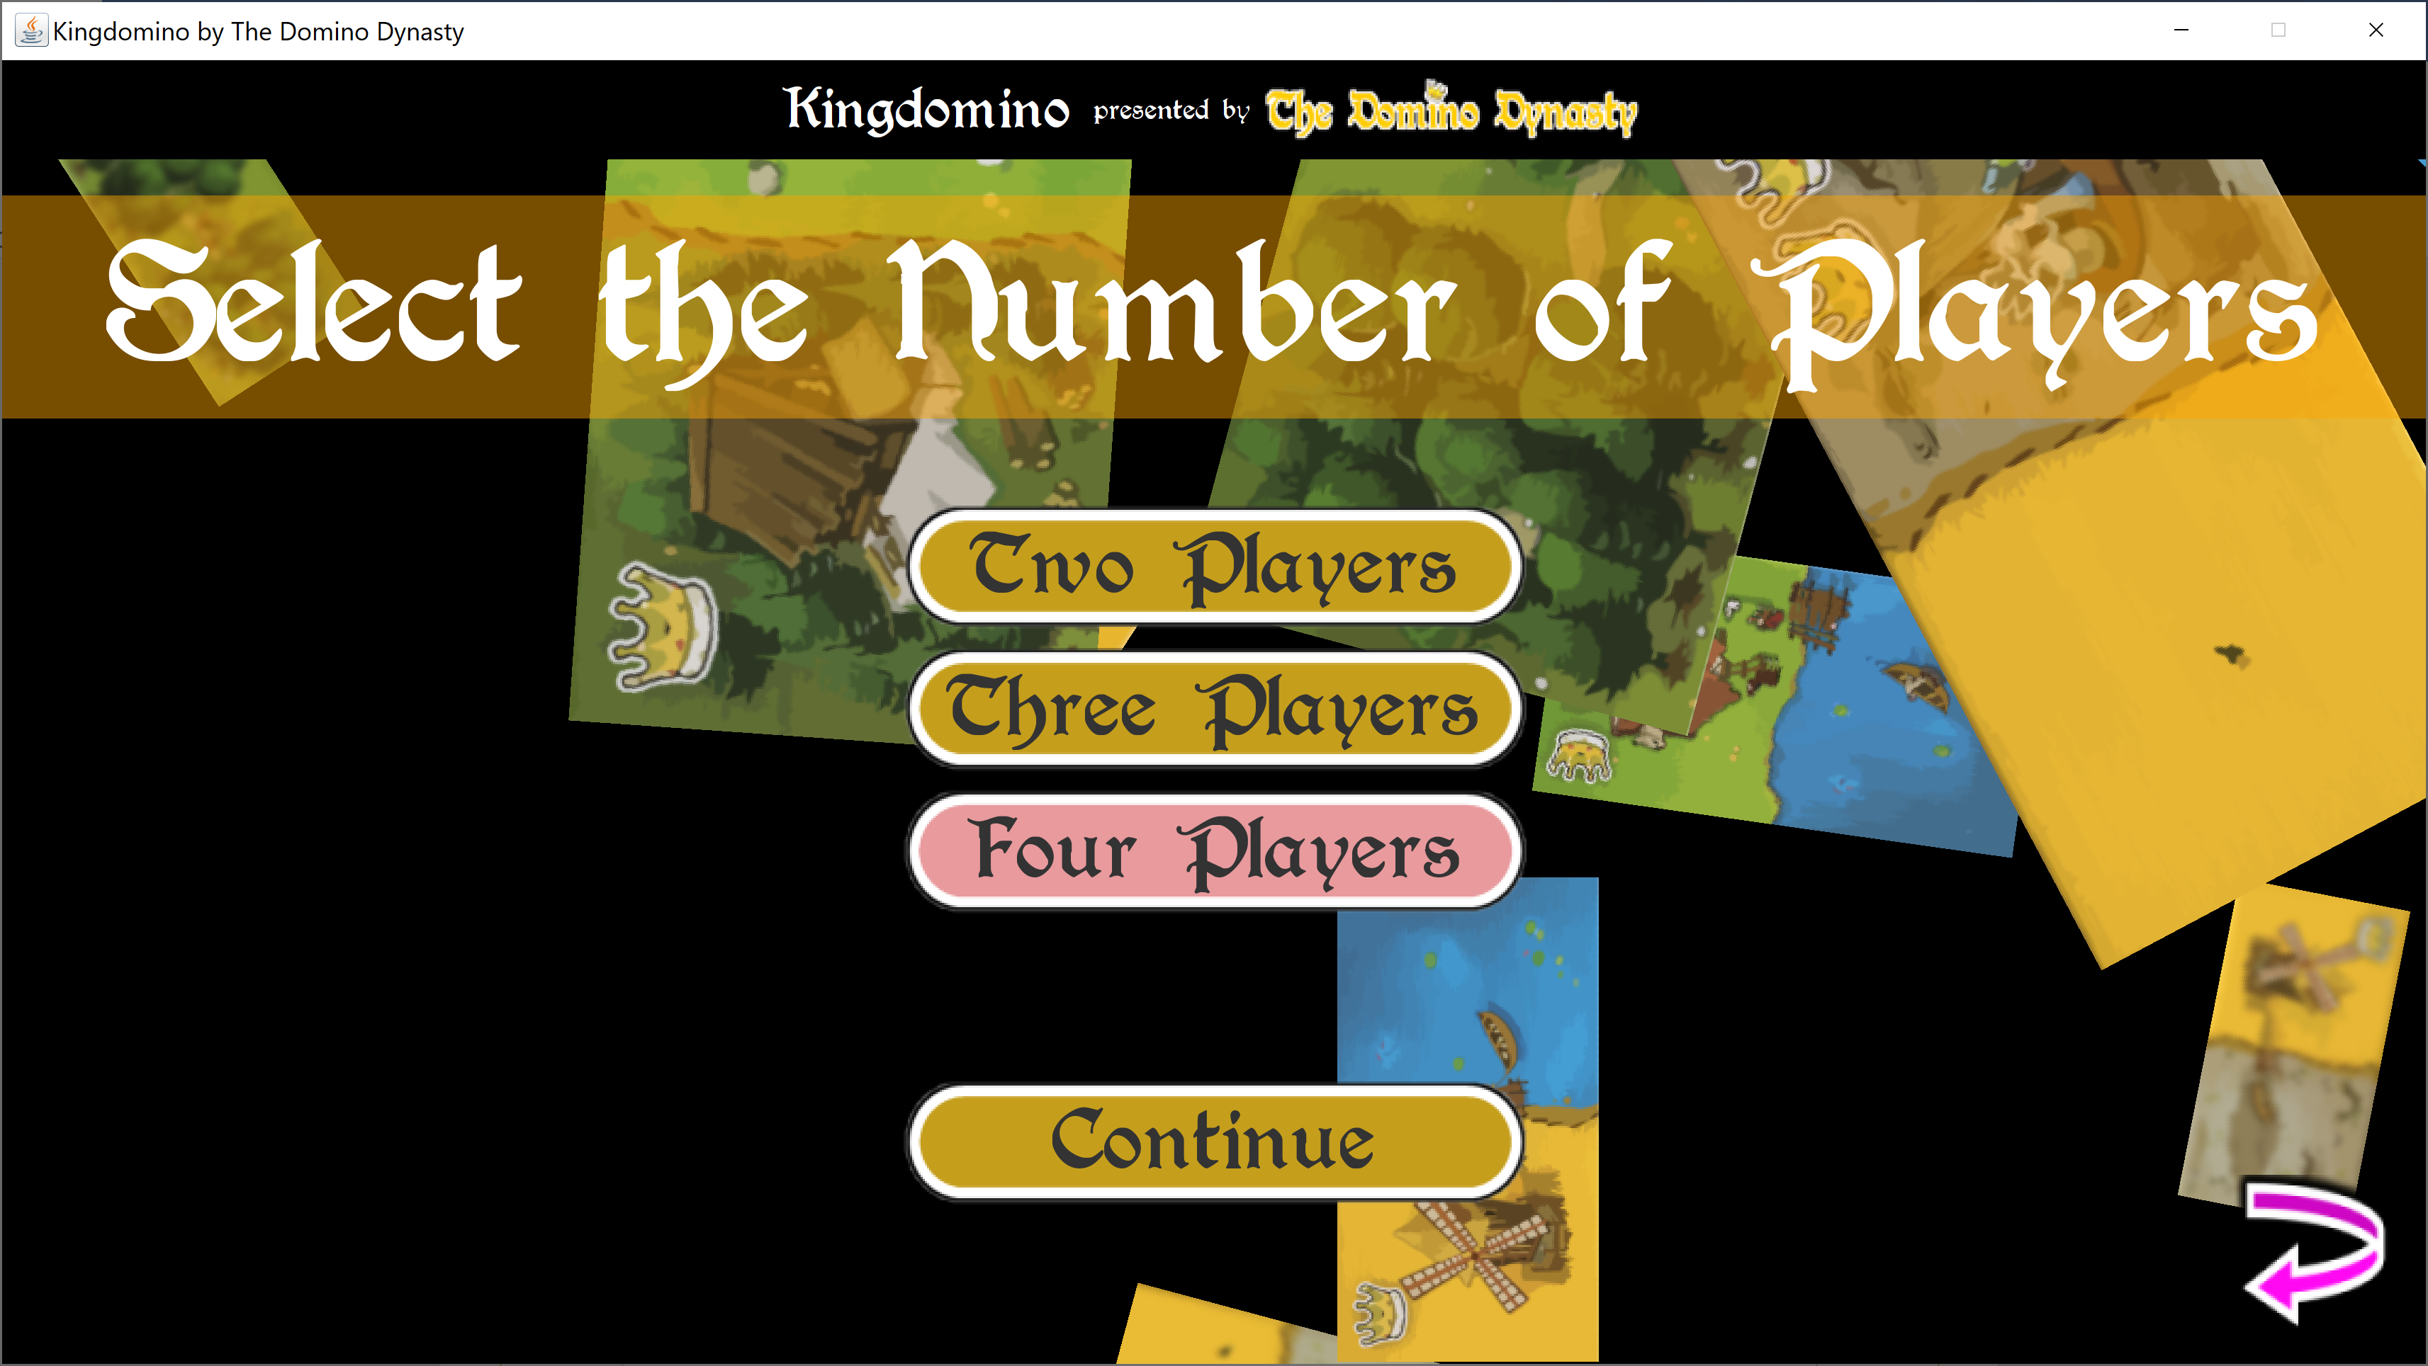

### 1. Two Players

Selecting this option generates a game for two players with 24 tiles. Players should then select “Continue” button to advance to the Player Name Entry screen.

### 2. Three Players

Selecting this option generates a game for three players with 36 tiles. Players should then select “Continue” button to advance to the Player Name Entry screen.

### 3. Four Players

Selecting this option generates a game for four players with 48 tiles. Players should then select “Continue” button to advance to the Player Name Entry screen.

## Player Name Entry

Upon entering the player name entry screen, players are able to enter each of their names based on the number of players selected on the previous screen. Each player is assigned a colored pawn next to their corresponding name entry box.

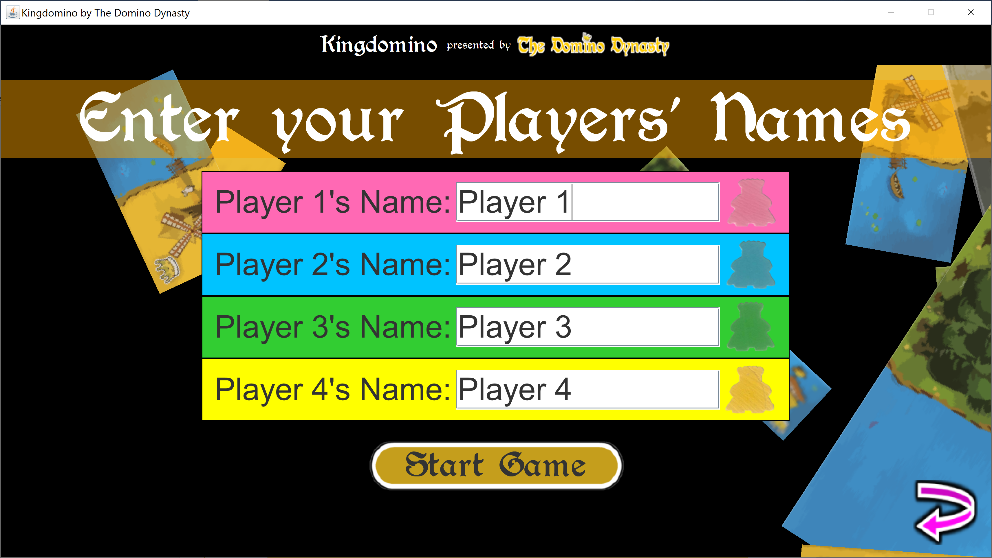

## Game Play Screen

Upon entering the game play screen, the game starts, and the first player begins their turn.

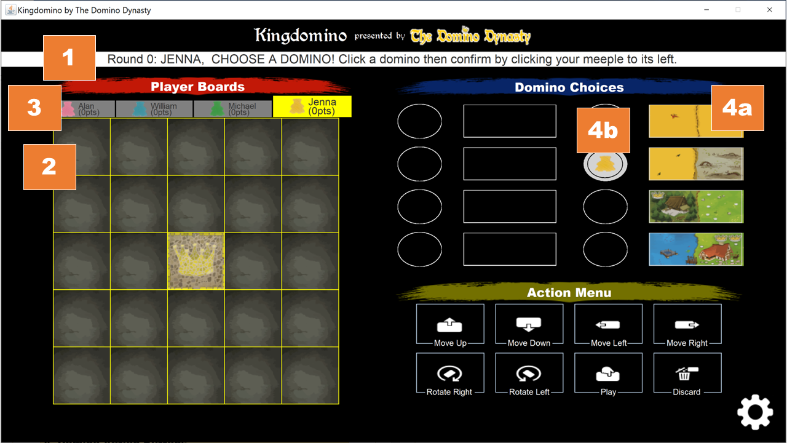

### 1. Status Info Bar

The current status of the game will be displayed in the game status info bar. Player turn, current action, and other prompts will be displayed here.

### 2. Player Board

The player board displays the current disposition of any domino pieces placed on the board. Players will select dominos and perform actions to manipulate their dominos into position on the player board.

### 3. Player Board View Buttons

The player game board view buttons will enable players to view the current disposition of other player’s game board.

### 4. Domino Selection Buttons

Players will first select a domino for the next round using the domino selection buttons, then confirm their selection by pressing their meeple icon next to the selected domino. A player may change their selected domino before confirming their selection. At the start of every round, dominos that had been selected for the next round (right column) will become dominos that are to be played for current round (left column). An animation will show the dominos sliding over to the left column, and new dominos will appear as dominos to be selected for the next round.

#### a. Domino Selection Buttons

Players must select a domino in this column. This represents the domino that the player will either play or discard during the next round.

#### b. Meeple Selection Buttons

After making their selection, players must press the corresponding meeple icon next to their selected domino.

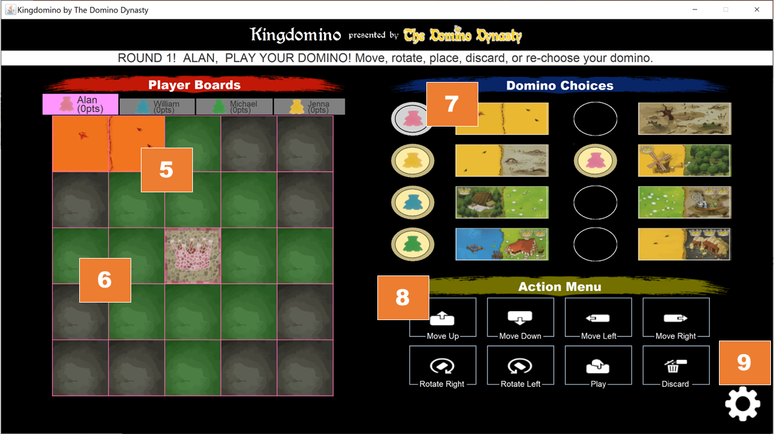

### 5. Domino Play on Player Board

After selecting a domino for the next round, if players have a domino to play for the current round, they will play it now. The domino that the player is playing for the current around will show on the player board. If it is in a playable position, the domino will appear normal. Otherwise, if it is not in a playable position, the domino will pulsate red. Players can use the Domino Action Buttons to move the domino into position to play, or discard the domino altogether.

### 6. Playable Area Overlay

While a player is playing a domino on their board, a green overlay will appear showing the player what possible positions the domino can be played at on their board.

### 7. Current Domino Display

The left most column displays the current domino that each player will play this round. The meeple icon next to the domino denotes which player will play that domino. As players play their dominos for the current round, the meeple and dominos will be removed to show round progression. Once all dominos have been played for the current round, play will progress to the next round. Next dominos will become current dominos, and play will continue in this fashion until the game ends. Note: there is no current domino for “Round 0”, thus play will immediately progress into the next round with players having played a domino for the current round.

### 8. Playable Area Overlay

All available domino choices for the current round are displayed; players may select a domino to add to their game board. A player may change their selected domino before performing the final “Place Domino” action, at which time the game will proceed to the next player in turn order.

#### a. Move Up

Players may click this button to move their domino up their grid

#### b. Move Down

Players may click this button to move their domino down their grid

#### c. Move Left

Players may use this button to move their domino to the left on their grid

#### d. Move Right

Players may use this button to move their domino to the right on their grid

#### e. Rotate Counter-Clockwise

Players may use this button to rotate their domino counter-clockwise on their grid

#### f. Rotate Clockwise

Players may use this button to rotate their domino clockwise on their grid

#### g. Place Domino

Players may use this button to place the domino on their grid

#### h. Discard Domino

Players may use this button to discard the domino and end their turn

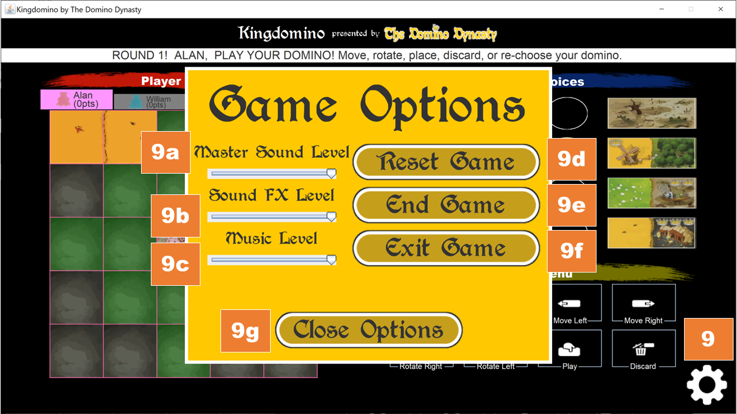

### 9. In-Game Option Menu

Players can click this button and have access to several options mid-game.

#### a. Master Sound Volume

This control changes the volume of both sound and music in the game.

#### b. Sound FX Volume

This control changes the volume of sound effects.

#### c. Music Volume

This control changes the music volume.

#### d. Reset Game

This button resets the game, keeping the same players.

#### e. End Game

This button ends the game and advances the game to the Score Screen.

#### f. Exit Game

This button exits the game.

#### g. Close Options

This button closes the in-game option menu.

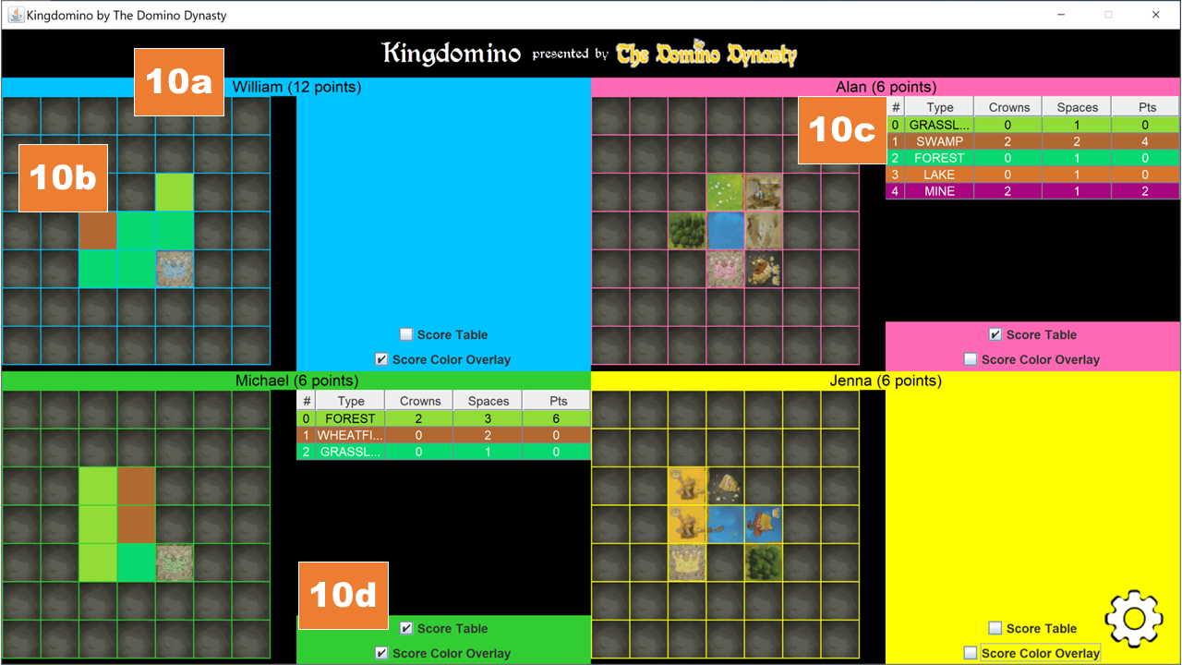

### 10. SCORE SCREEN

At the end of the game, a score screen will display each player’s score and contain several options that be toggled to display scoring details. Players will be ordered by highest score, then in case of tie, by highest number of crowns, then by largest contagious scoring area.

#### a. Player Information

The player’s name and final score will be displayed at the top.

#### b. Player Board

The player’s game board is displayed here. The “Score Color Overlay” and “Score Table” are initially turned on to display additional scoring information.

#### c. Player Score Table

This table displays each score group, consisting of the land type, number of crowns, number of spaces, and total points achieved from scoring this group. The table can be toggled on or off.

#### d. Player Score Toggle Options

The player score toggle options consist of two separate options: one that can toggle the Score Table on or off and one that can toggle the color group overlay display on the player board on or off.

## Troubleshooting

### What if the Game Doesn’t Start?

#### Confirm that Your System is Running Java 8

1. Open Command Prompt
2. Type “java – version” without quotation marks
3. Verify that you have Java 8 or higher installed

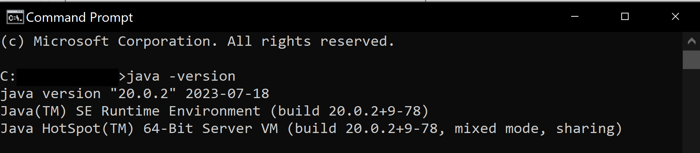

#### 1. Try Running the Game from the Command Prompt

1. Open Command Prompt
2. Navigate to where the executable JAR file is located
3. Type “java -jar pathtoJARfile.jar”, where pathtoJARfile is the file path

#### 2. Encounter a bug?

Email us at @thedominodynasty@groups.outlook.com.



KINGDOMINO

# 6. TEST PLAN & RESULTS

## Introduction

Product testing will be an integral part of the development of the Kingdomino digital board game. Testing will be comprehensive and exhaustive to ensure that the product operates according to the project specifications. Feedback from testers and quality control personnel will be used to incorporate fixes and updates to the product as desired.

## Objectives

* Implement a testing system that catalogues all inputs and outcomes
* Ensure that all testing feedback is incorporated into product development
* Ensure that the program functions properly according to the project specifications

## Scope

The scope of the test plan will entail implementing a testing regime that supports the successful creation of a digital Kingdomino board game that incorporates the project specifications. This includes ensuring that all of the game play mechanics of the physical board are present in the final product.

## Strategy

The testing strategy will involve testing all areas required in accordance with the project specifications and ensure that desired outcomes are observed. We will implement the testing by capturing inputs and outcomes for each of the GUI display screens, ensuring correct functionality throughout.

## Phases II & III: Functionality to be Tested

Note: Clicking a numbered heading goes directly to the corresponding portion in the Test Cases part of this document.

### 1. Start Screen

* 1. Display
  2. Start button
  3. Music

### 2. Main Menu Options Screen

* 1. Display
  2. Start Button
  3. How to Play Button
  4. Credits Button
  5. Exit Button
  6. Back Button
  7. Music

### 3. How to Play Screen

* 1. Display
  2. Left Button
  3. Right Button
  4. Back Button
  5. Music

### 4. Credits

* 1. Display
  2. Back Button
  3. Music

### 5. Player Number Select Screen

* 1. Display
  2. Two Players Button
  3. Three Players Button
  4. Four Players Button
  5. Continue Button
  6. Back Button
  7. Music

### 6. Player Name Entry Screen

* 1. Display
  2. Player Labels
  3. Player Name Entry Text Boxes
  4. Start Button
  5. Back Button
  6. Music

### 7. Game Play Screen

* 1. Display
  2. Player Board View Buttons
  3. Player Board
  4. Domino Selection Buttons
  5. Domino Action Buttons
  6. Status Information Banner
  7. Domino Choices Panel Animations
  8. Player Board Animations
  9. Pop-up Errors
  10. In-Game Option Button
  11. Music

### 8. Score Screen

* 1. Display
  2. Player Boards
  3. Player Board Labels
  4. Score Table
  5. Score Table Toggle
  6. Player Board Score Color Overlay Toggle
  7. In-Game Option Button
  8. Music

### 9. Pre-Game Back Button

* 1. Display
  2. Click Sound
  3. Mouse Over
  4. Mouse Exit
  5. Click Function

### 10. Menu Button Functionality

* 1. Display & Positioning
  2. Click Sound
  3. Mouse Over
  4. Mouse Exit
  5. Click Function
  6. Player Number Screen Select Function

### 11. In-Game Options Menu

* 1. Display & Positioning
  2. Master Volume Slider
  3. Sound Effects Volume Slider
  4. Music Volume Slider
  5. Reset Game Button
  6. End Game Button
  7. Exit Game Button
  8. Close Options Button

## Test Cases

### 1. Start Screen

|  |  |  |  |  |
| --- | --- | --- | --- | --- |
| Test # 1 | Input/Action | Expected Output | Actual Output | Pass? |
| Test # 1-1 Display | Start program | Program starts with no errors; all objects display in panel correctly | Program starts with no errors; all objects display in panel correctly | Yes |
| Test # 1-2 Button | Click “Click to Start” button | Program proceeds to next screen | Program proceeds to next screen | Yes |
| Test # 1-3 Music | Start program | Music correctly plays at the start of program; loops continuously | Music correctly plays at the start of program; loops continuously | Yes |

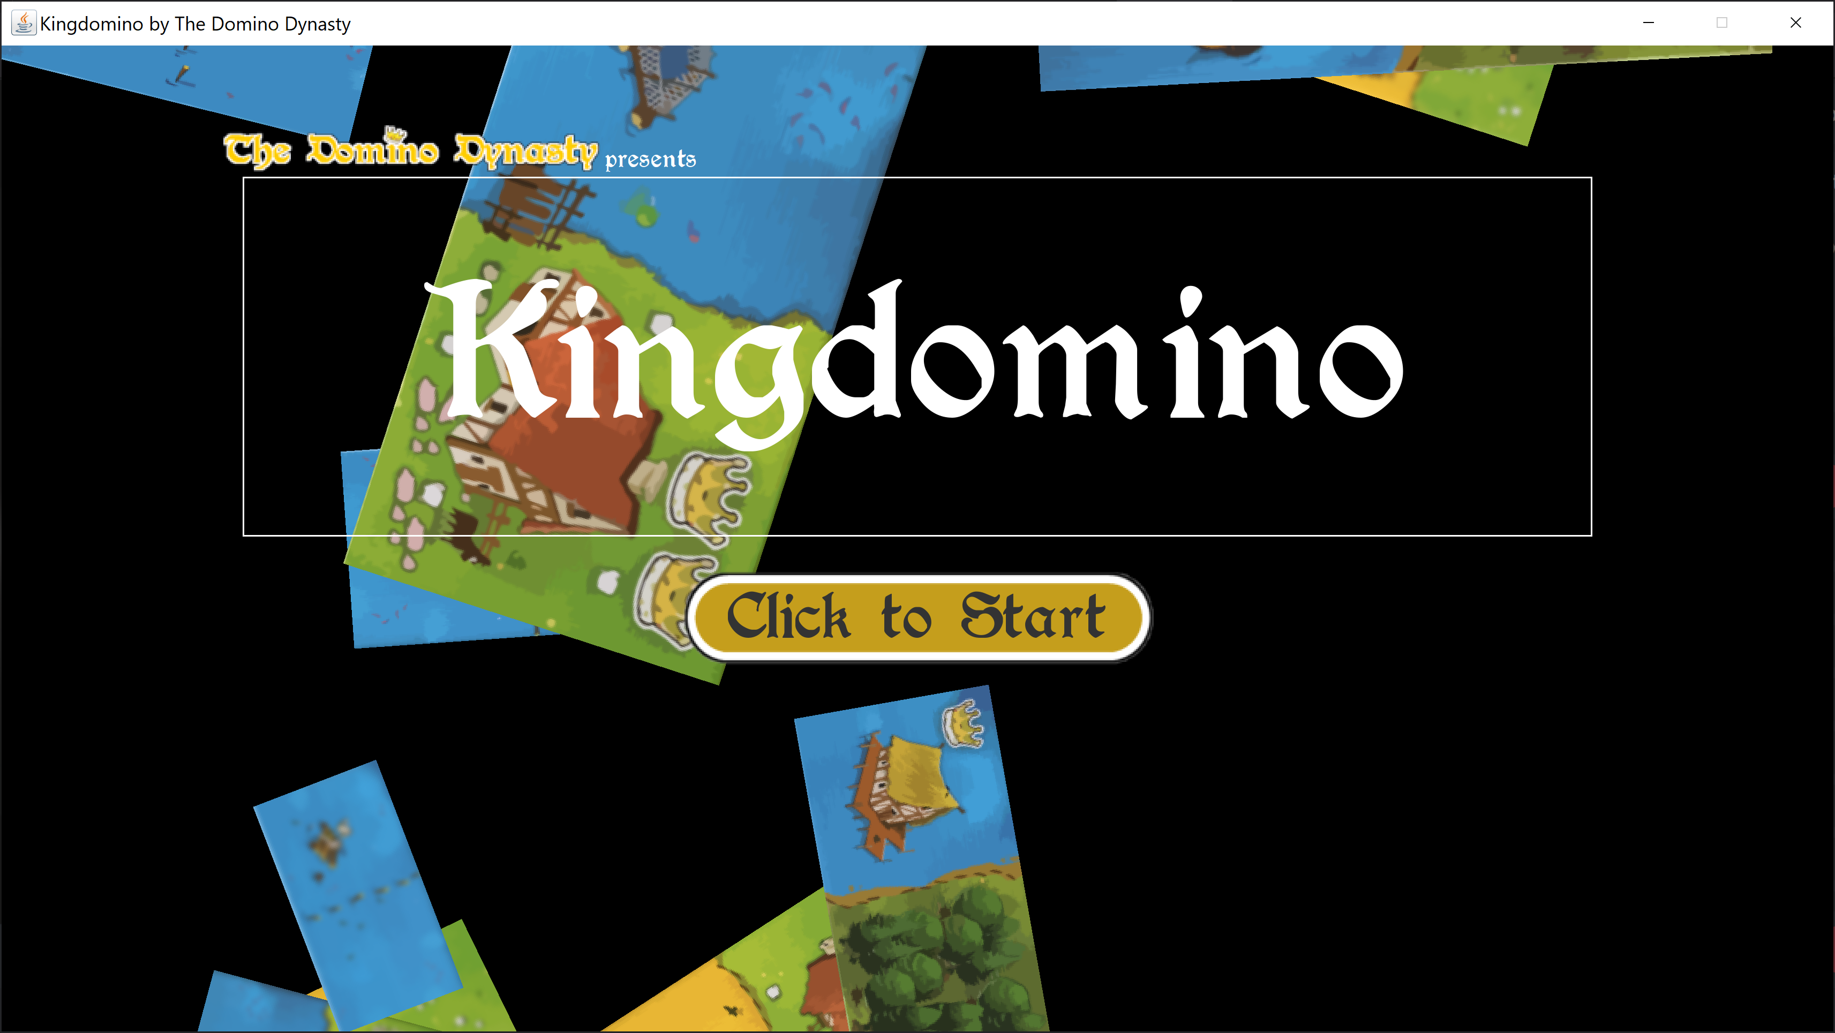

### Main Menu Options Screen

|  |  |  |  |  |
| --- | --- | --- | --- | --- |
| Test # 2 | Input/Action | Expected Output | Actual Output | Pass? |
| Test # 2-1 Display | Enter display screen | All objects display in panel correctly | All objects display in panel correctly | Yes |
| Test # 2-2 Start button | Click Play Game button | Program proceeds to Player Number Selection screen | Program proceeds to Player Number Selection screen | Yes |
| Test # 2-3 How to Play button | Click How to Play button | Program proceeds to How to Play screen | Program proceeds to How to Play screen | Yes |
| Test # 2-4 Credits button | Click Credits button | Program proceeds to Credits Screen | Program proceeds to Credits Screen | Yes |
| Test # 2-5 Exit button | Click Exit button | Program exits | Program exits | Yes |
| Test # 2-6 Back button | Click Back button | Program goes back to Start screen | Program goes back to Start screen | Yes |
| Test # 2-7 Music | Start program | Music continues to play correctly | Music continues to play correctly | Yes |

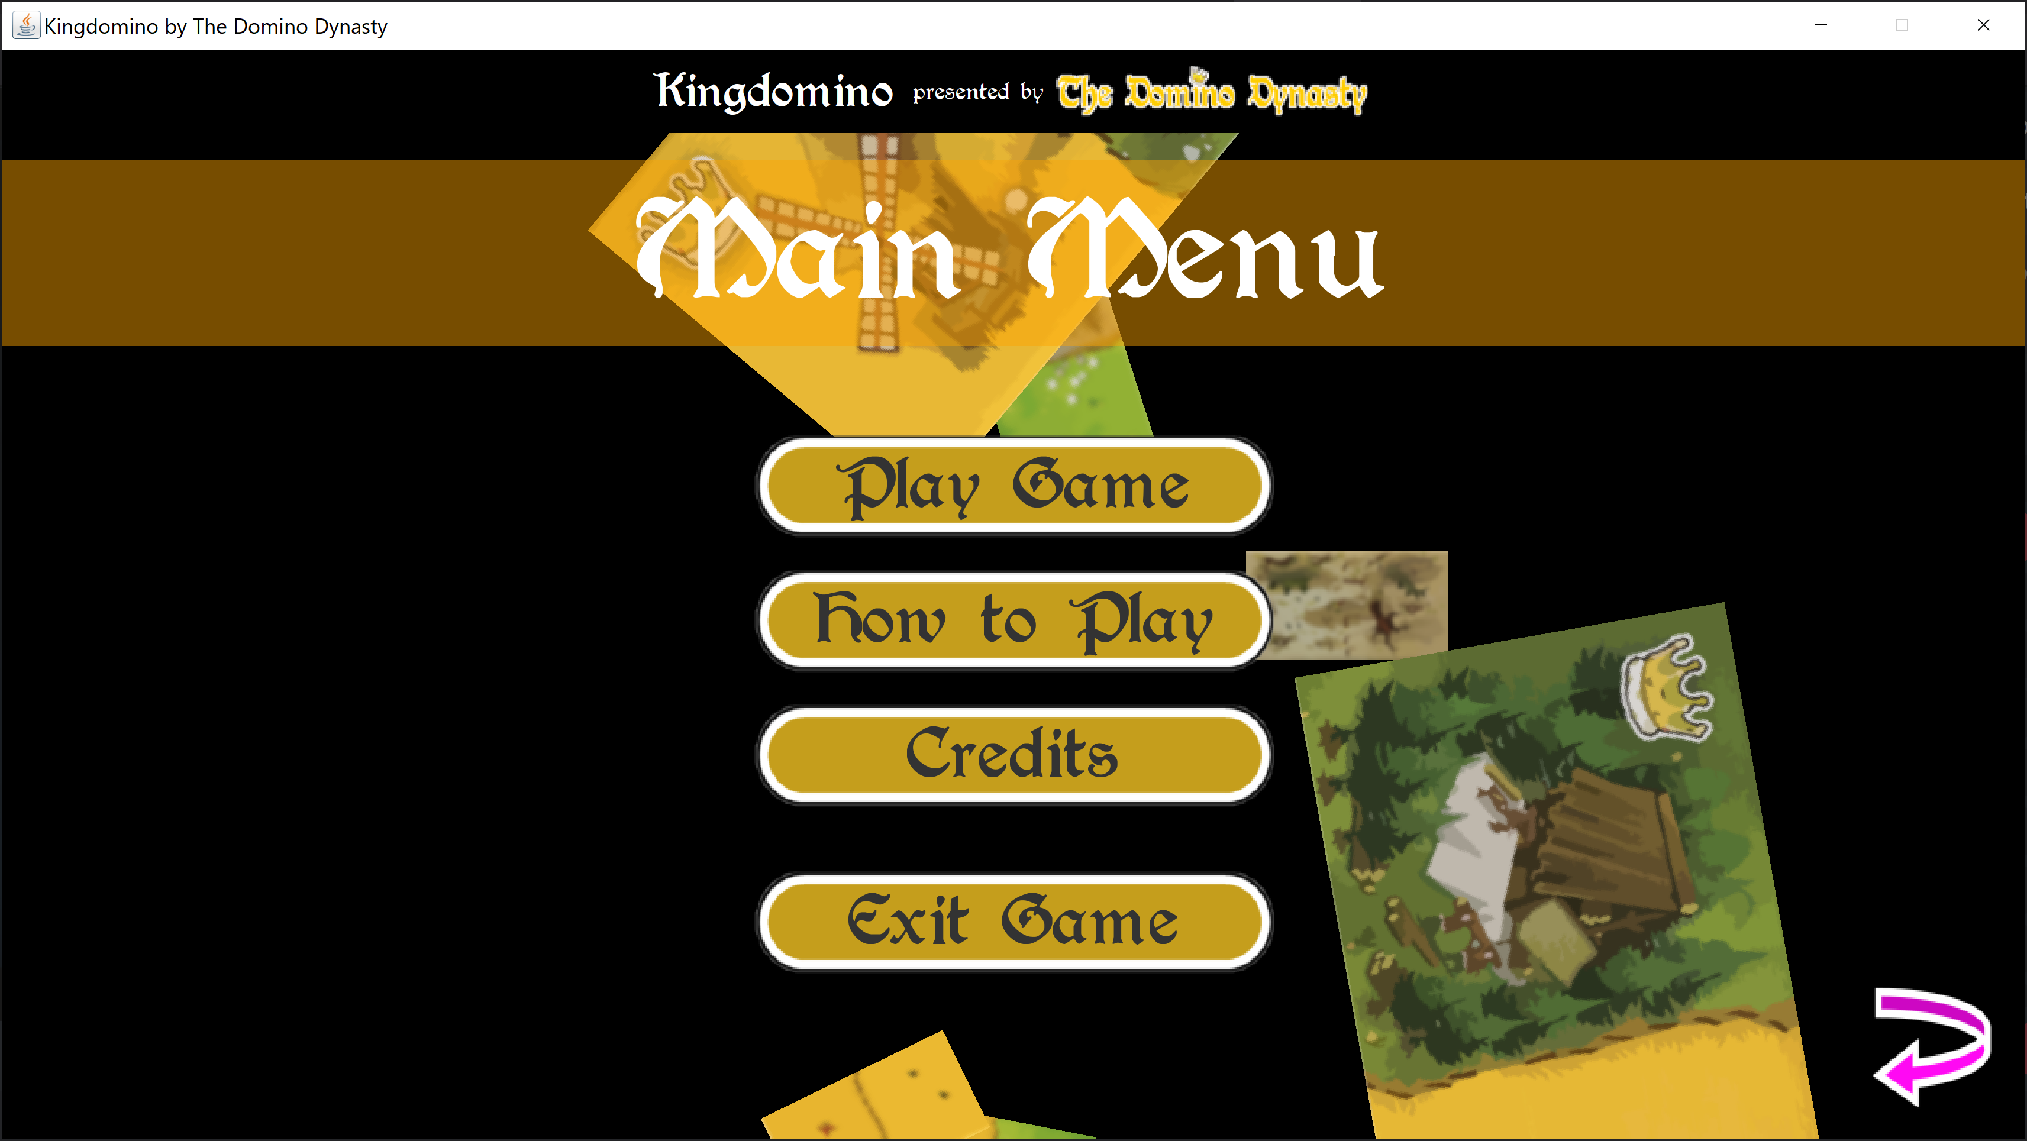

### How to Play Screen

|  |  |  |  |  |
| --- | --- | --- | --- | --- |
| Test # 3 | Input/Action | Expected Output | Actual Output | Pass? |
| Test # 3-1 Display | Enter display screen | All objects display in panel correctly | All objects display in panel correctly | Yes |
| Test # 3-2 Left Button | Click Left button | Instructions proceed to next text block; eventually stops at last text block | Instructions proceed to next text block; eventually stops at last text block | Yes |
| Test # 3-3 Right button | Click Right button | Instructions go back to previous text block; eventually stops at first block | Instructions go back to previous text block; eventually stops at first block | Yes |
| Test # 3-4 Back button | Click Back button | Program goes back to Main Menu Options screen | Program goes back to Main Menu Options screen | Yes |
| Test # 3-5 Music | Start Program | Music continues to play correctly | Music continues to play correctly | Yes |

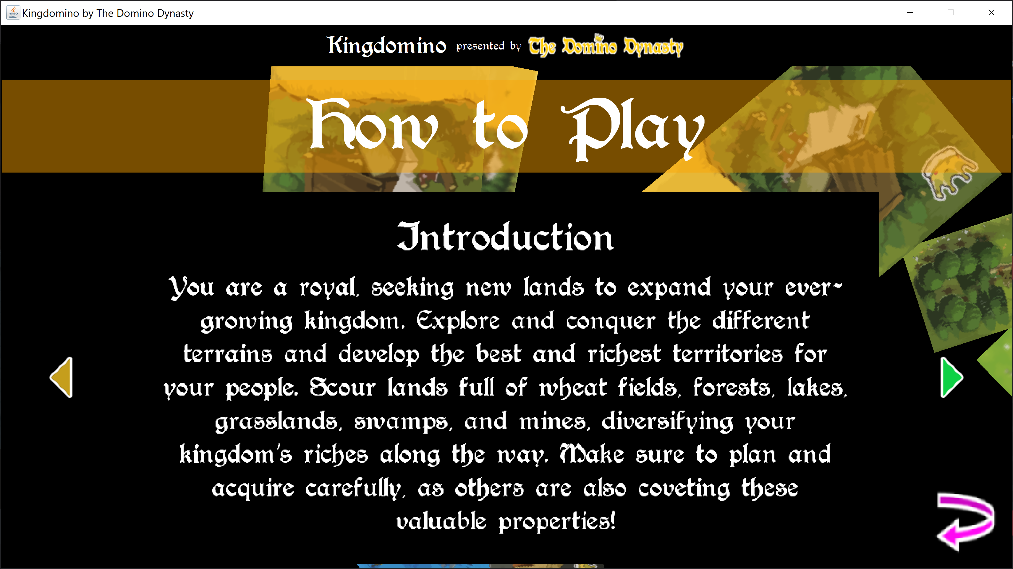

### Credits Screen

|  |  |  |  |  |
| --- | --- | --- | --- | --- |
| Test # 4 | Input/Action | Expected Output | Actual Output | Pass? |
| Test # 4-1 Display test | Enter display screen | All objects display in panel correctly | All objects display in panel correctly | Yes |
| Test # 4-2 Back button | Click Back button | Program goes back to Main Menu Options screen | Program goes back to Main Menu Options screen | Yes |
| Test # 4-3 Music | Start Program | Music continues to play correctly | Music continues to play correctly | Yes |

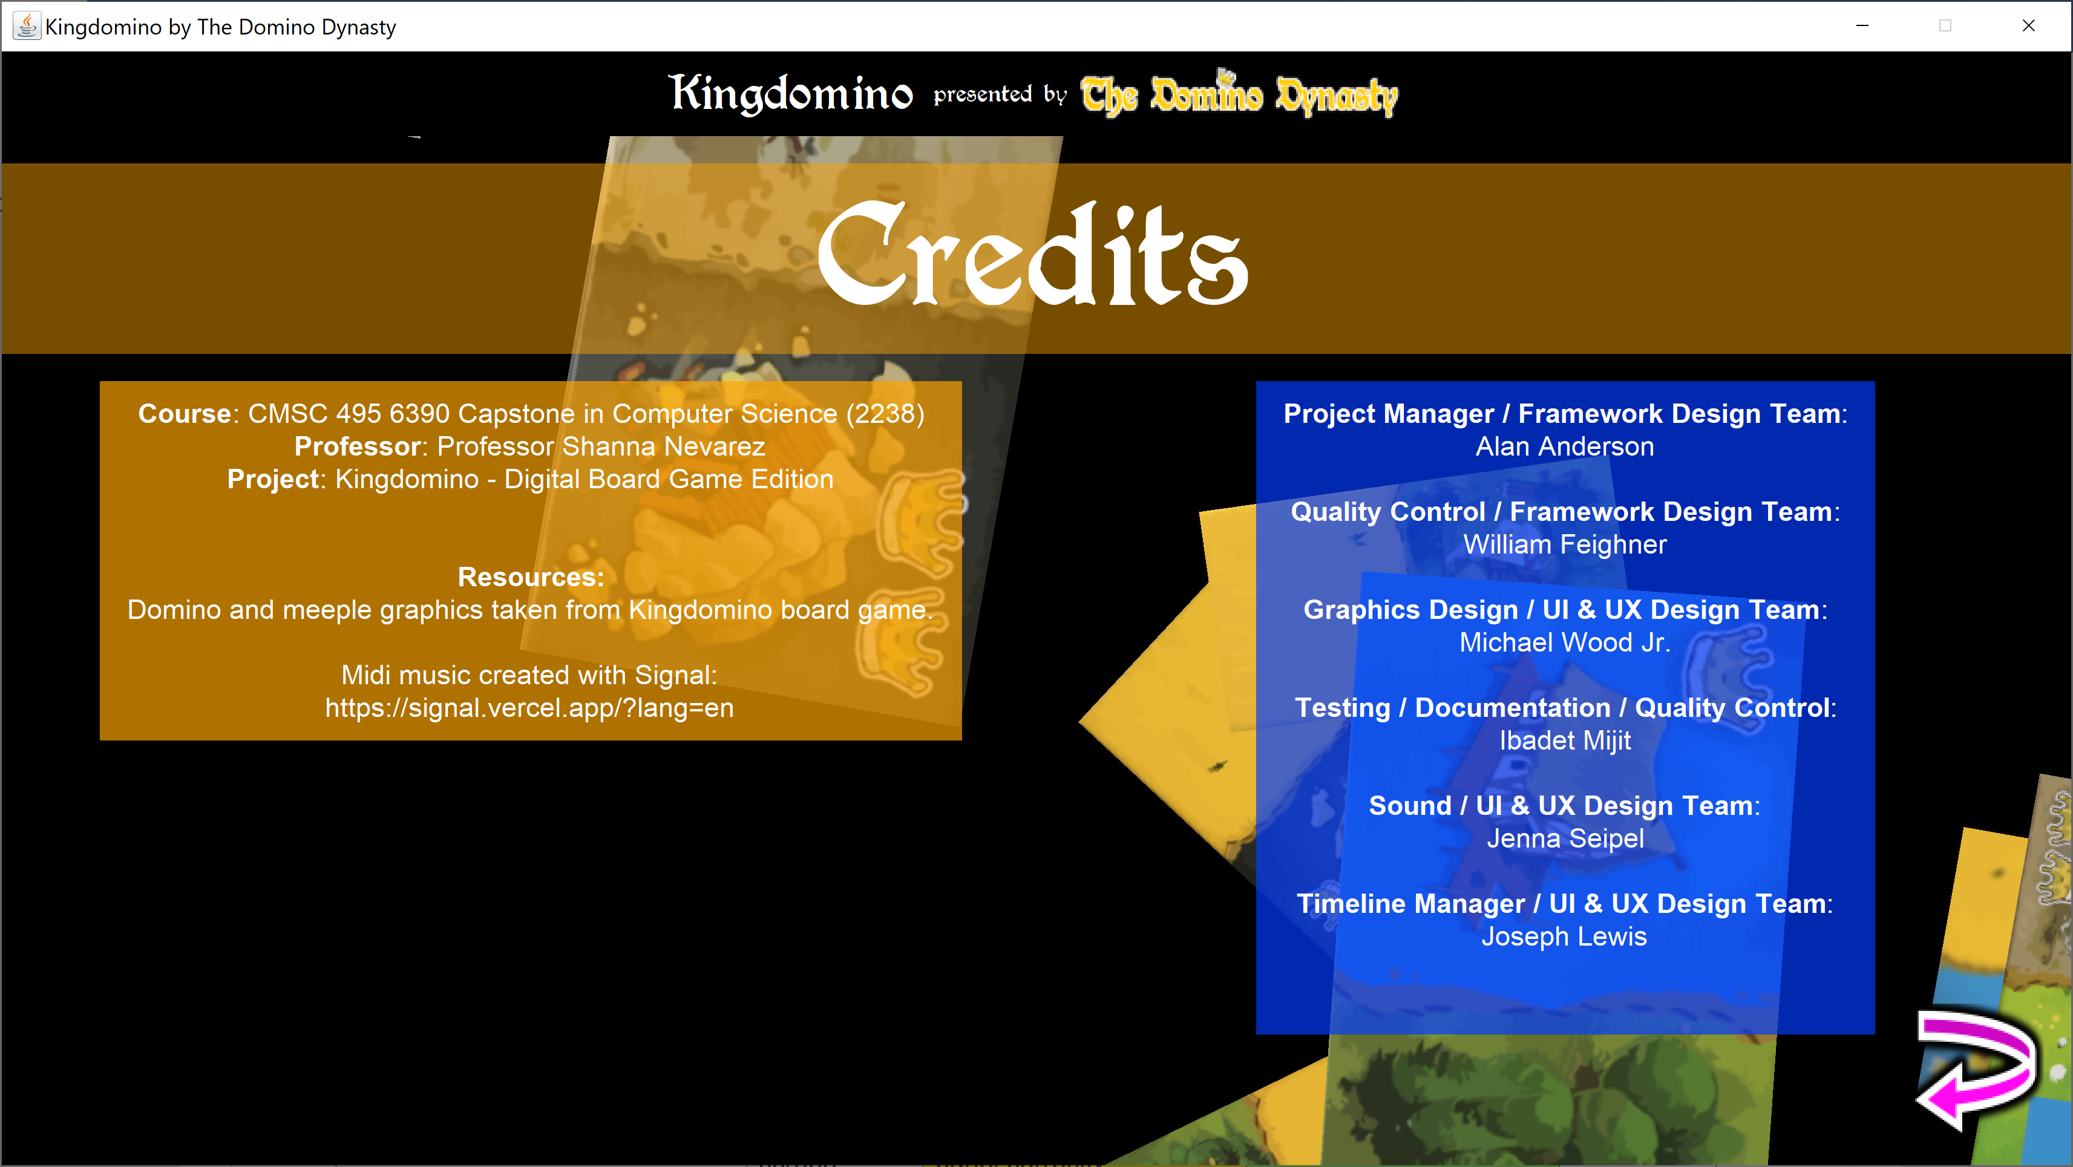

### Player Number Selection Screen

|  |  |  |  |  |
| --- | --- | --- | --- | --- |
| Test # 5 | Input/Action | Expected Output | Actual Output | Pass? |
| Test # 5-1 Display test | Enter display screen | All objects display in panel correctly | All objects display in panel correctly | Yes |
| Test # 5-2 Two Players button | Click Two Players button | Button correctly stays highlighted after being selected; produces name entry for two players on next screen | Button correctly stays highlighted after being selected; produces name entry for two players on next screen | Yes |
| Test # 5-3 Three Players button | Click Three Players button | Button correctly stays highlighted after being selected; produces name entry for three players on next screen | Button correctly stays highlighted after being selected; produces name entry for three players on next screen | Yes |
| Test # 5-4 Four Players button | Click Four Players button | Button correctly stays highlighted after being selected; produces name entry for four players on next screen | Button correctly stays highlighted after being selected; produces name entry for four players on next screen | Yes |
| Test # 5-5 Continue button | Click Continue button | Continue button is not visible until a player number button is selected. Once selected, continue button proceeds game to the Player Name Entry display | Continue button is not visible until a player number button is selected. Once selected, continue button proceeds game to the Player Name Entry display | Yes |
| Test # 5-6 Back button | Click Back button | Program goes back to Main Menu Options screen | Program goes back to Main Menu Options screen | Yes |
| Test # 5-7 Music test | Start Program | Music continues to play correctly | Music continues to play correctly | Yes |

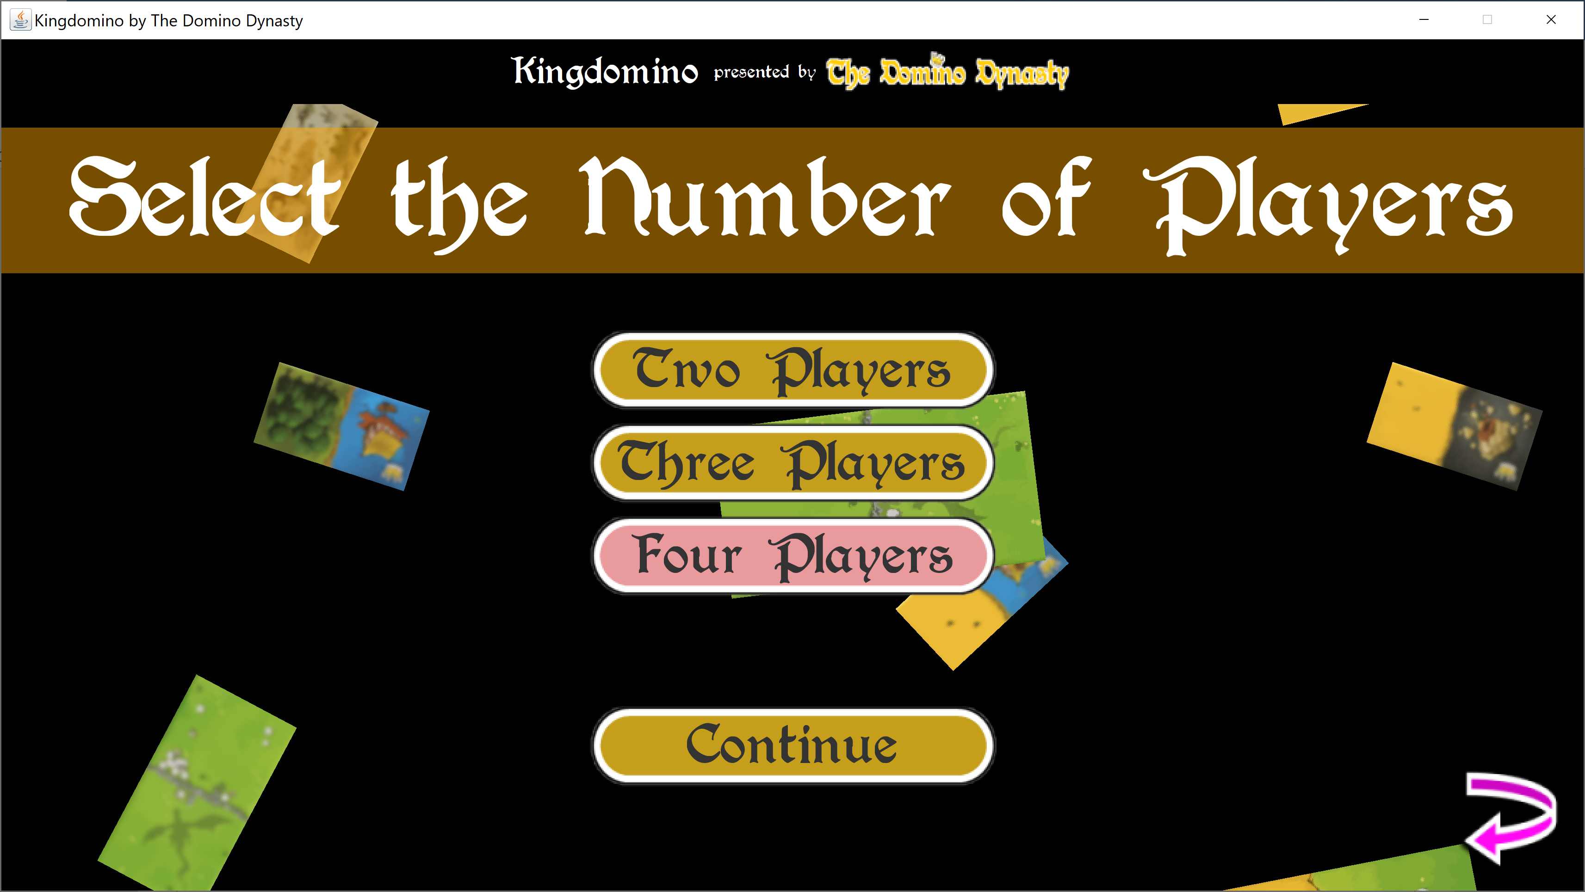

### Player Name Entry Screen

|  |  |  |  |  |
| --- | --- | --- | --- | --- |
| Test # 6 | Input/Action | Expected Output | Actual Output | Pass? |
| Test # 6-1 Display | Enter display screen | All objects display in panel correctly | All objects display in panel correctly | Yes |
| Test # 6-2 Player labels | Enter display screen | Labels display correct player number, player color, and meeple color | Labels display correct player number, player color, and meeple color | Yes |
| Test # 6-3 Player name entry text boxes | Type in Player name entry text box | Text box correctly captures and displays input. Text input limited to 10 characters only. | Text box correctly captures and displays input. Text input limited to 10 characters only. | Yes |
| Test # 6-4 Start Game button | Click Start Game button | Game proceeds to Game Play screen. Player names are displayed correctly next screen. | Game proceeds to Game Play screen. Player names are displayed correctly next screen. | Yes |
| Test # 6-5 Music test | Start Program | Music continues to play correctly | Music continues to play correctly | Yes |

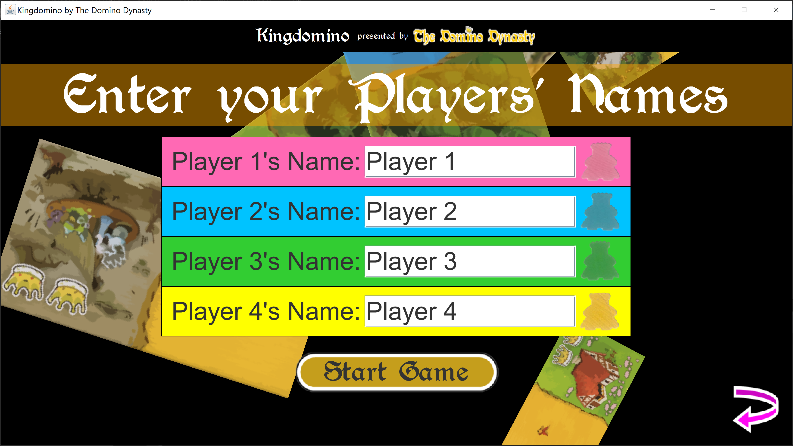

#### Game Play Screen

|  |  |  |  |  |
| --- | --- | --- | --- | --- |
| Test # 7 | Input/Action | Expected Output | Actual Output | Pass? |
| Test # 7-1 Display | Enter display screen | All objects display in panel correctly | All objects display in panel correctly | Yes |
| Test # 7-2-a Player Board View tab buttons | Click a player board view button | Switches to appropriate player board. Plays a sound and changes color to denote an action has been conducted | Switches to appropriate player board. Plays a sound and changes color to denote an action has been conducted | Yes |
| Test # 7-2-b Player Board View tab buttons | Place and score a domino | Player board view button updates with correct current player score | Player board view button updates with correct current player score | Yes |
| Test # 7-3 Player Board | Click domino then click a domino action | Domino manipulation is correctly displayed on player board; sounds play correctly for each action | Domino manipulation is correctly displayed on player board; sounds play correctly for each action | Yes |
| Test # 7-4 Domino button | Click domino button to select a domino | Domino button highlights green; current player board shows domino on their board at starting position | Domino button highlights green; current player board shows domino on their board at starting position | Yes |
| Test # 7-5-a Move Up action after a domino has been selected | Click Move Up button | Domino moves its position upward on player board; error message displays if movement is impossible | Domino moves its position upward on player board; error message displays if movement is impossible | Yes |

|  |  |  |  |  |
| --- | --- | --- | --- | --- |
| Test # 7-5-b Move Down action after a domino has been selected | Click Move Down button | Domino moves its position downward on player board; error message displays if movement is impossible | Domino moves its position downward on player board; error message displays if movement is impossible | Yes |
| Test # 7-5-c Move Left action after a domino has been selected | Click Move Left button | Domino moves its position to left on player board; error message displays if movement is impossible | Domino moves its position to left on player board; error message displays if movement is impossible | Yes |
| Test # 7-5-d Move Right action after a domino has been selected | Click Move Right button | Domino moves its position right on Milit player board; error message displays if movement is impossible | Domino moves its position right on Milit player board; error message displays if movement is impossible | Yes |
| Test # 7-5-e Rotate left action after a domino has been selected | Click Rotate Left button | Domino rotates left on player board; error message displays if movement is impossible | Domino rotates left on player board; error message displays if movement is impossible | Yes |
| Test # 7-5-f Rotate left action after a domino has been selected | Click Rotate Right button | Domino rotates right on player board; error message displays if movement is impossible | Domino rotates right on player board; error message displays if movement is impossible | Yes |

|  |  |  |  |  |
| --- | --- | --- | --- | --- |
| Test # 7-5-g Place domino action after a domino has been selected | Click Place Domino button | Domino is placed on player board if placement possible; player’s meeple now shown in place of selected domino; play proceeds to next player and/or next round; next player’s board now shown in board display; error message if domino can’t be placed | Domino is placed on player board if placement possible; player’s meeple now shown in place of selected domino; play proceeds to next player and/or next round; next player’s board now shown in board display; error message if domino can’t be placed | Yes |
| Test # 7-5-h Discard domino action after a domino has been selected | Click Discard Domino button | Domino is discarded; player’s meeple now shown in place of selected domino; play proceeds to next player and/or next round; next player’s board now shown in board display; error message if domino can’t be placed | Domino is discarded; player’s meeple now shown in place of selected domino; play proceeds to next player and/or next round; next player’s board now shown in board display; error message if domino can’t be placed | Yes |
| Test # 7-6 Status info bar | Enter display screen | Current game round, current player, and current action are displayed correctly in status info bar | Current game round, current player, and current action are displayed correctly in status info bar | Yes |

|  |  |  |  |  |
| --- | --- | --- | --- | --- |
| Test # 7-7 Domino choices panel animations | Transition between rounds; select dominos | Dominos for next round correctly appear 1 by 1 accompanied by sound; domino and meeple animations fire upon mouse over and mouse exit; domino and meeple buttons appear to “shift left” between round transitions | Dominos for next round correctly appear 1 by 1 accompanied by sound; domino and meeple animations fire upon mouse over and mouse exit; domino and meeple buttons appear to “shift left” between round transitions | Yes |
| Test # 7-8 Player board animations | Automatic animations when placing domino | Domino to be placed on player board pulsates red if at an unplayable position; player board highlights green all possible playable areas for the current domino | Domino to be placed on player board pulsates red if at an unplayable position; player board highlights green all possible playable areas for the current domino | Yes |
| Test # 7-9 Pop-up Errors | Perform an action that generates an error | Error popups display correctly and are successfully dispelled with one click | Error popups display correctly and are successfully dispelled with one click | Yes |
| Test # 7-10 In-game options button | Click gear at bottom right | Opens the in-game options menu | Opens the in-game options menu | Yes |
| Test # 7-11 Music | Enter display screen | Menu music stops; game play music plays correctly | Menu music stops; game play music plays correctly | Yes |

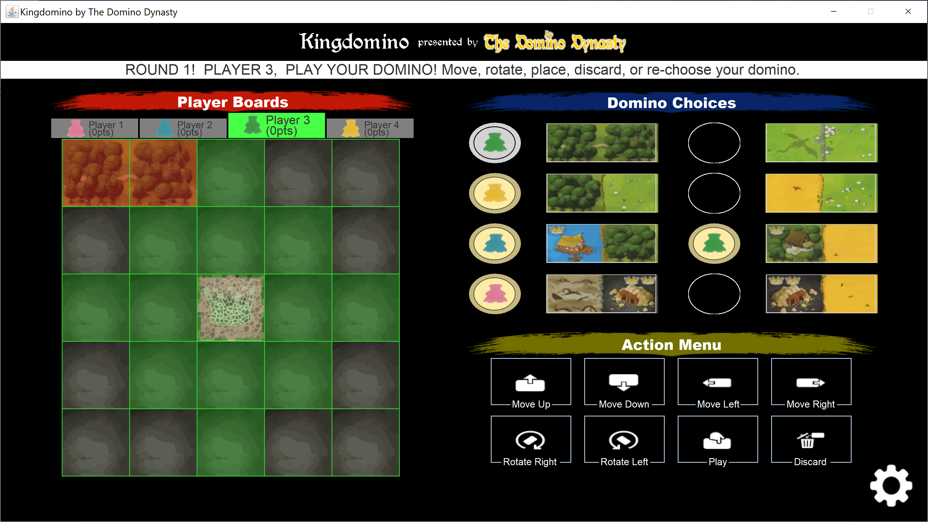

#### Score Screen

|  |  |  |  |  |
| --- | --- | --- | --- | --- |
| Test # 8 | Input/Action | Expected Output | Actual Output | Pass? |
| Test # 8-1 Display | Enter Score Screen | All objects display in panel correctly | All objects display in panel correctly | Yes |
| Test # 8-2 Player boards | Enter Score Screen | Player boards have correctly captured all of the player’s domino plays and displays correctly | Player boards have correctly captured all of the player’s domino plays and displays correctly | Yes |
| Test # 8-3 Player board labels | Enter Score Screen | Player board labels correctly display player names and scores | Player board labels correctly display player names and scores | Yes |
| Test # 8-4 Score table | Enter Score Screen | Each player score table correctly displays the game board’s score groups | Each player score table correctly displays the game board’s score groups | Yes |
| Test # 8-5 Score table toggle | Click “Score Table” checkbox | Correctly makes score table visible or invisible | Correctly makes score table visible or invisible | Yes |
| Test # 8-6 Player board score color overlay toggle | Click “Score Color Overlay” checkbox | Correctly displays a color grouping over player board tiles when checked; displays normal dominos when unchecked | Correctly displays a color grouping over player board tiles when checked; displays normal dominos when unchecked | Yes |
| Test # 8-7 In-game options button | Click gear at bottom right | Opens the in-game options menu | Opens the in-game options menu | Yes |
| Test # 8-8 Music | Enter Score Screen | Music continues to play; game end fanfare plays briefly over music | Music continues to play; game end fanfare plays briefly over music | Yes |

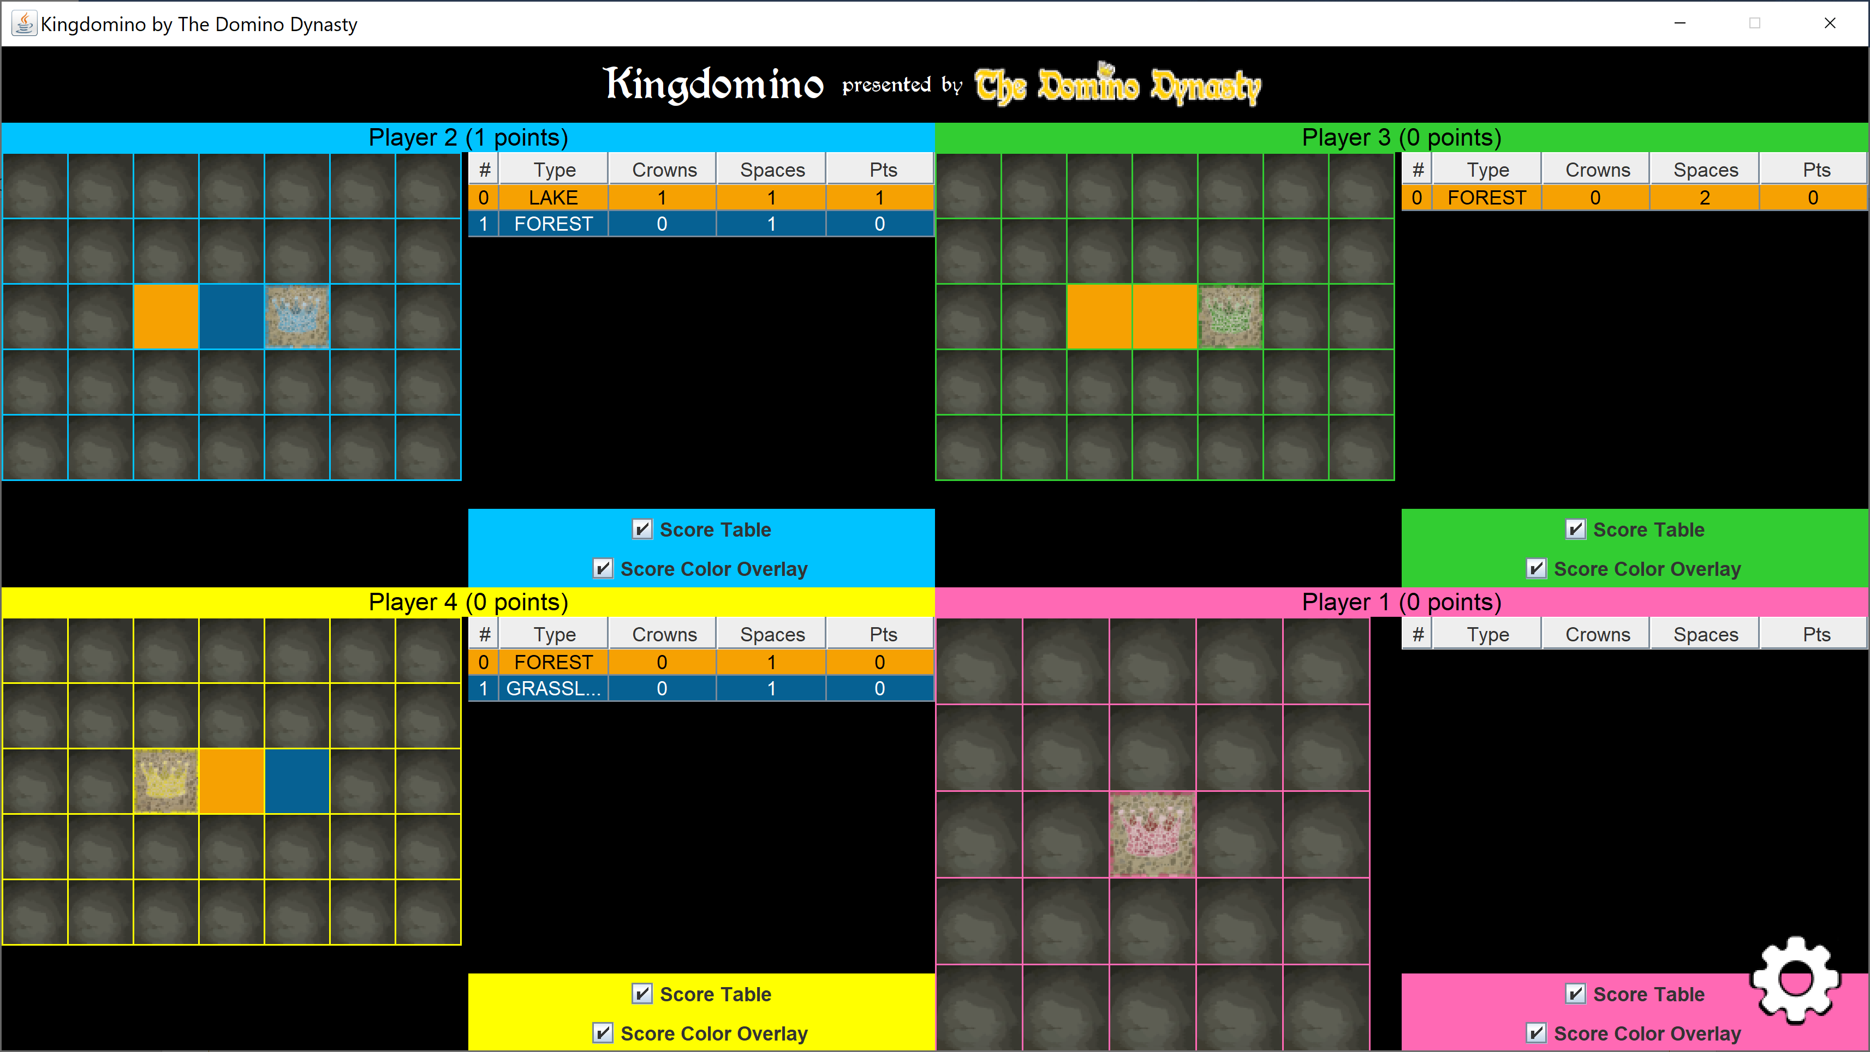

#### Pre-Game Back Button

|  |  |  |  |  |
| --- | --- | --- | --- | --- |
| Test # 9 | Input/Action | Expected Output | Actual Output | Pass? |
| Test # 9-1 Back Button display and position | Enter display with back button enabled | Back button correctly displays at bottom right of every screen except for the Start Screen, Game Play Screen, and Score screens | Back button correctly displays at bottom right of every screen except for the Start Screen, Game Play Screen, and Score screens | Yes |
| Test # 9-5 Back Button Click Sound | Click Back Button | Click sound is produced when button is clicked | Click sound is produced when button is clicked | Yes |
| Test # 9-2 Back Button Mouse Enter action | Mouse over Back Button | Back button becomes larger | Back button becomes larger | Yes |
| Test # 9-3 Back Button Mouse Exit action | Mouse exit Back Button | Back button becomes smaller | Back button becomes smaller | Yes |
| Test # 9-4 Back Button Click | Click Back Button | Display goes back to previous screen; sound plays when back button is clicked; button made invisible on start screen | Display goes back to previous screen; sound plays when back button is clicked; button made invisible on start screen | Yes |

#### 10. Menu Button Functionality

|  |  |  |  |  |
| --- | --- | --- | --- | --- |
| Test # 10 | Input/Action | Expected Output | Actual Output | Pass? |
| Test # 10-1 Button Display & Positioning | Enter screens that display menu button | Menu buttons are correctly positioned in each screen display; buttons are centered horizontally; buttons are not clipped or off screen | Menu buttons are correctly positioned in each screen display; buttons are centered horizontally; buttons are not clipped or off screen | Yes |
| Test # 10-2 Click sound | Click a menu button | Menu button plays clicking sound when clicked | Menu button plays clicking sound when clicked | Yes |
| Test # 10-3 Mouse over color change | Mouse over menu button | Menu button changes color when moused over | Menu button changes color when moused over | Yes |
| Test # 10-4 Mouse exit color change | Mouse exit menu button | Menu button changes color when mouse exited | Menu button changes color when mouse exited | Yes |
| Test # 10-5 Mouse clicked color change | Click menu button | Menu button changes color; reverts back to original color on mouse button release | Menu button changes color; reverts back to original color on mouse button release | Yes |
| Test # 10-6 Mouse selected color change for Player Number Selection screen | Click a menu button for Player Number | Menu button color remains changed even on mouse entry or exit; reverts back to original color if a different Player Number button is clicked | Menu button color remains changed even on mouse entry or exit; reverts back to original color if a different Player Number button is clicked | Yes |

#### 11. In-Game Option Menu

|  |  |  |  |  |
| --- | --- | --- | --- | --- |
| Test # 11 | Input/Action | Expected Output | Actual Output | Pass? |
| Test # 11-1 Display & Positioning | Open in-game option menu | Menu displays correctly in center of screen and houses all required sliders and buttons | Menu displays correctly in center of screen and houses all required sliders and buttons | Yes |
| Test # 11-2 Master slider volume | Adjust Master Volume slider to the left and right | Slider displays correctly; adjusting master slider adjusts both sound effects and music volume | Slider displays correctly; adjusting master slider adjusts sound effects, but distorts midi music and does not effectively reduce volume; midi returns to previous volume on loop | No; various attempts to fix midi bug resulted in same output |
| Test # 11-3 Sound effects volume slider | Adjust Sound FX slider to the left and right | Slider displays correctly; adjusting Sound FX Volume slider adjusts the volume up and down as intended | Slider displays correctly; adjusting Sound FX Volume slider adjusts the volume up and down as intended | Yes |
| Test # 11-4 Music volume slider | Adjust Music Volume slider to the left and right | Slider displays correctly; adjusting Music Volume slider adjusts the volume up and down as intended | Slider displays correctly; adjusting Music Volume distorts midi music and does not effectively reduce volume; midi returns to previous volume on loop | No; various attempts to fix midi bug resulted in same output |

|  |  |  |  |  |
| --- | --- | --- | --- | --- |
| Test # 11-5 Reset game button | Click Reset Game button | Correctly resets game back to starting state; if not in game play screen, immediate displays game play screen | Correctly resets game back to starting state; if not in game play screen, immediate displays game play screen | Yes |
| Test # 11-6 End Game Button | Click End Game button | Ends the game and progresses to the Score Screen | Ends the game and progresses to the Score Screen | Yes |
| Test # 11-6 Exit Game Button | Click Exit Game button | Exits the game | Exits the game | Yes |
| Test # 11-6 Close Options button | Click Close Options button | Closes the in-game options screen | Closes the in-game options screen | Yes |

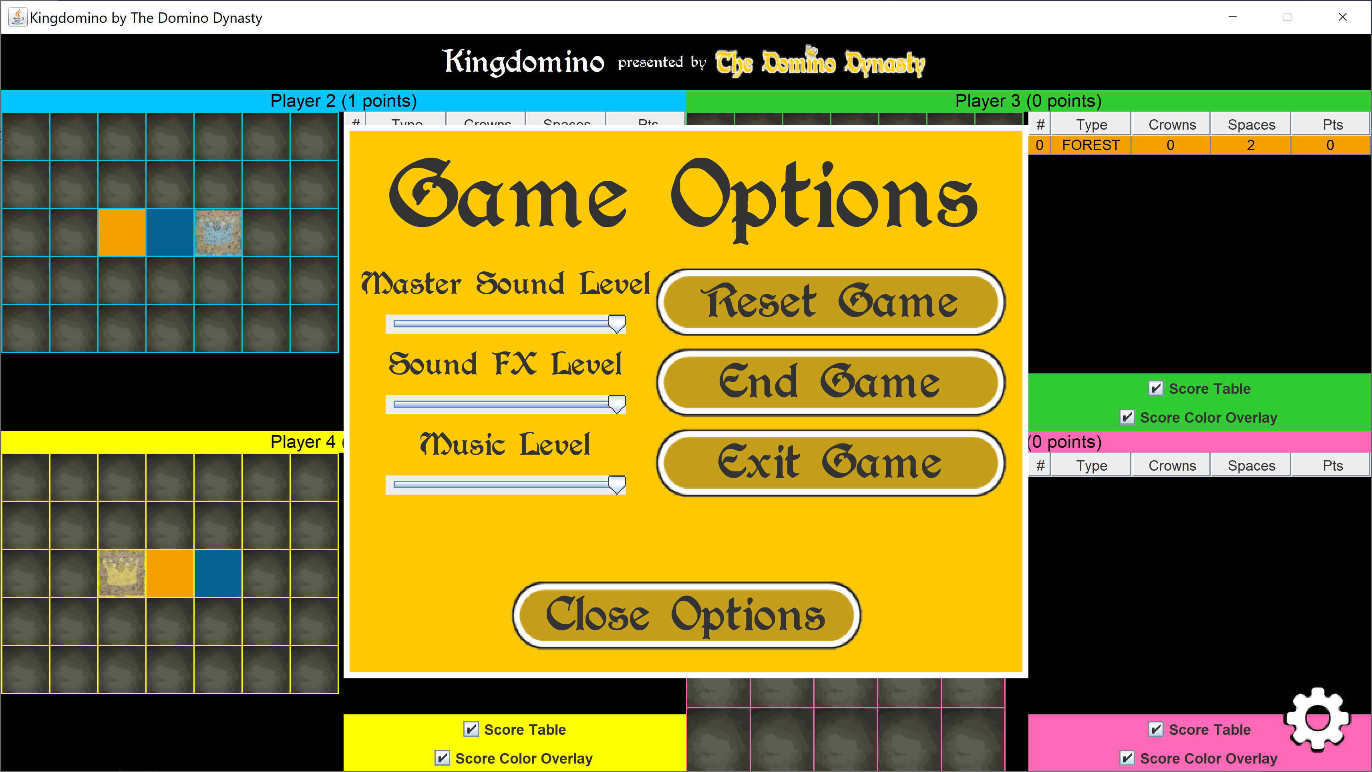

## Phase I: Functionality to be Tested

Note: Each heading links to its portion in the Test Cases part of this document.

### Title

* 1. Display

### Player Name Menu

* 1. Display
  2. Two Players
  3. Two Players
  4. Four Players

### Player Name Menu

* 1. Display
  2. Name Entry

### Domino Selection Menu

* 1. Display
  2. Choose a Domino

### Domino Placement Menu

* 1. Display
  2. Rotate Clockwise
  3. Rotate Counter Clockwise
  4. Move Up
  5. Move Down
  6. Move Left
  7. Move Right
  8. Place Tile in Current Position
  9. Discard Domino

### Game End

* 1. Display

## Test Cases

### 1. Title

|  |  |  |  |  |
| --- | --- | --- | --- | --- |
| Test # 1 | Input/Action | Expected Output | Actual Output | Pass? |
| Test # 1-1 Display | Start program | Program starts with no errors; title and first menu display correctly | Program starts with no errors; title and first menu display correctly | Yes |

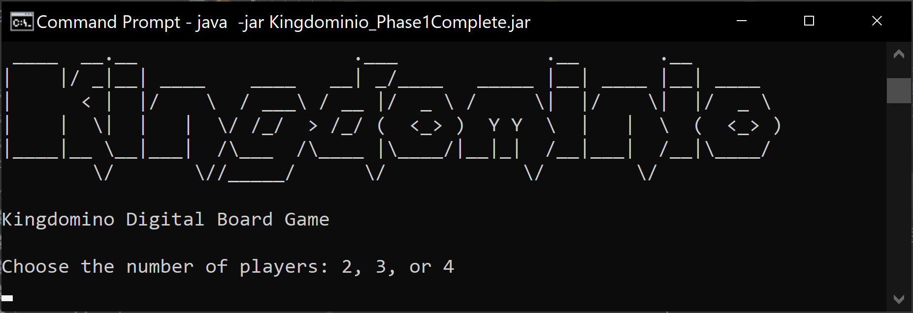

### 2. Player Number Menu

|  |  |  |  |  |
| --- | --- | --- | --- | --- |
| Test # 2 | Input/Action | Expected Output | Actual Output | Pass? |
| Test # 2-1 Display | Start program | Menu displays correctly with no errors | Menu displays correctly with no errors | Yes |
| Test # 2-2 Two players | Type “2”, press Enter | Game proceeds to Player Name Entry menu | Game proceeds to Player Name Entry menu | Yes |
| Test # 2-3 Three players | Type “3”, press Enter | Game proceeds to Player Name Entry menu | Game proceeds to Player Name Entry menu | Yes |
| Test # 2-4 Four players | Type “4”, press Enter | Game proceeds to Player Name Entry menu | Game proceeds to Player Name Entry menu | Yes |

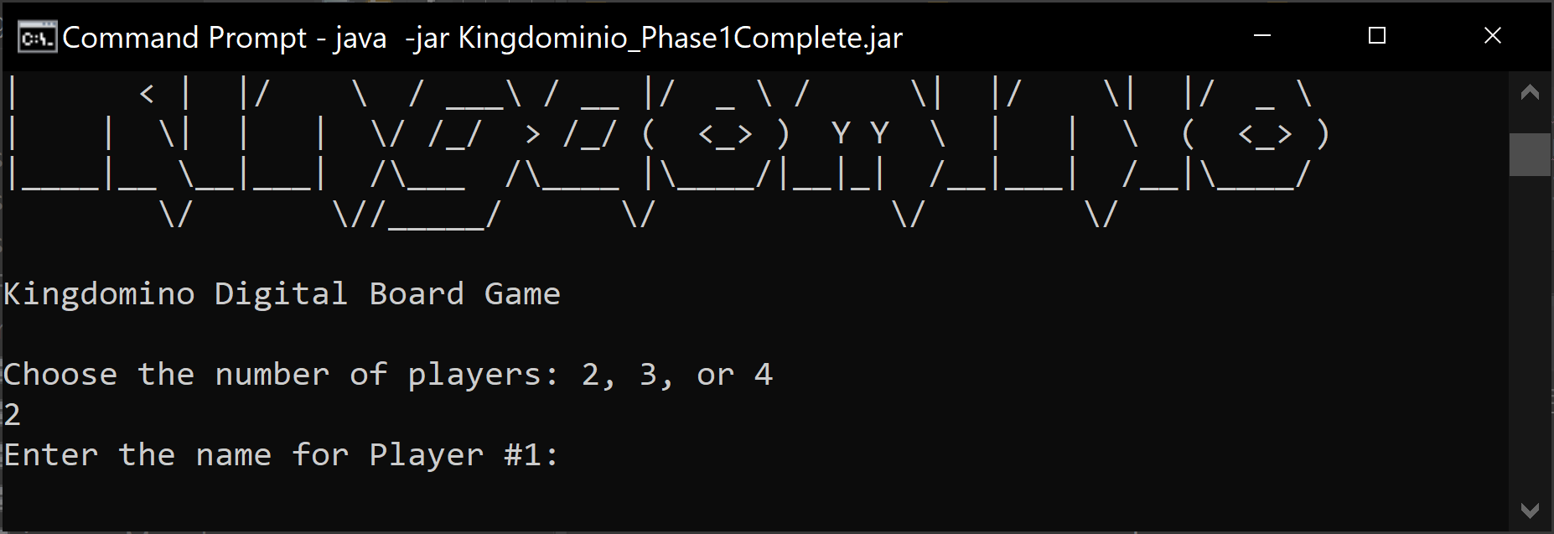

### 3. Player Name Menu

|  |  |  |  |  |
| --- | --- | --- | --- | --- |
| Test # 3 | Input/Action | Expected Output | Actual Output | Pass? |
| Test # 3-1 Display | Start program | Menu displays correctly with no errors | Menu displays correctly with no errors | Yes |
| Test # 3-2 Name Entry | Type name, Press Enter | Names get entered successfully; upon creating a name for each player, the game starts, with the current round and game board layout for the current player being displayed; turn order is also shown | Names get entered successfully; upon creating a name for each player, the game starts, with the current round and game board layout for the current player being displayed; turn order is also shown | Yes |
| Test # 3-3 Name Entry for 2 players | Type name, Press Enter | For two players, each player enters name once, then a copy of those players is assigned the copied name plus additional text signaling the copy; the game starts, with the current round and game board layout for the current player being displayed; turn order is also shown | For two players, each player enters name once, then a copy of those players is assigned the copied name plus additional text signaling the copy; the game starts, with the current round and game board layout for the current player being displayed; turn order is also shown | Yes |

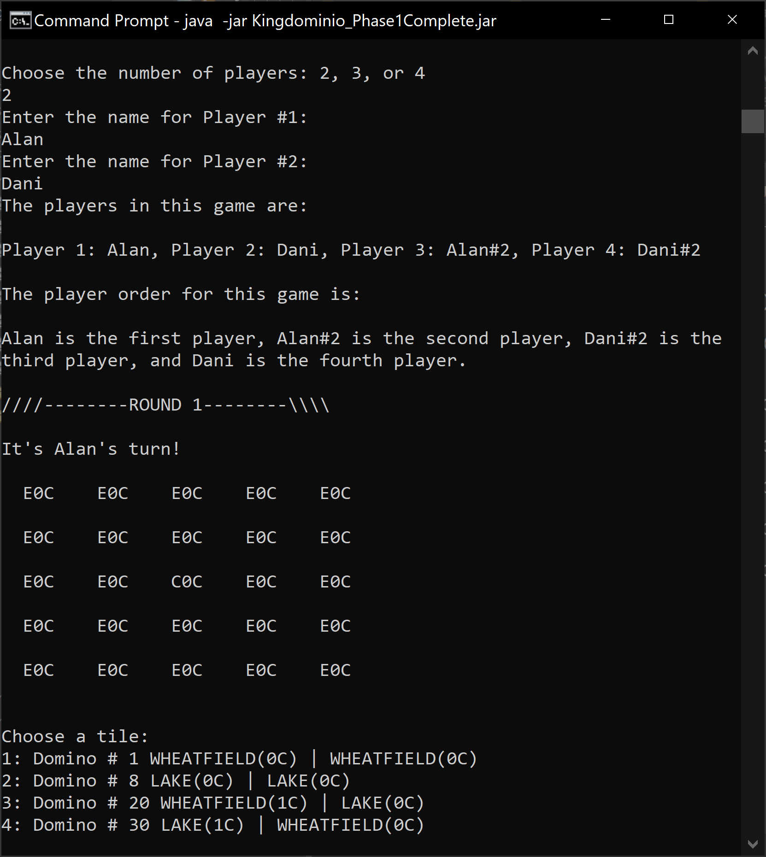

### 4. Domino Selection Menu

|  |  |  |  |  |
| --- | --- | --- | --- | --- |
| Test # 4 | Input/Action | Expected Output | Actual Output | Pass? |
| Test # 4-1 Display | Start program | Menu displays correctly with no errors | Menu displays correctly with no errors | Yes |
| Test # 4-2 Choose a Domino | Type domino number; press Enter | Upon entering domino number, the player board is displayed showing the selected domino at the top left of the player board; options for moving the domino follow immediately after player board display | Upon entering domino number, the player board is displayed showing the selected domino at the top left of the player board; options for moving the domino follow immediately after player board display | Yes |

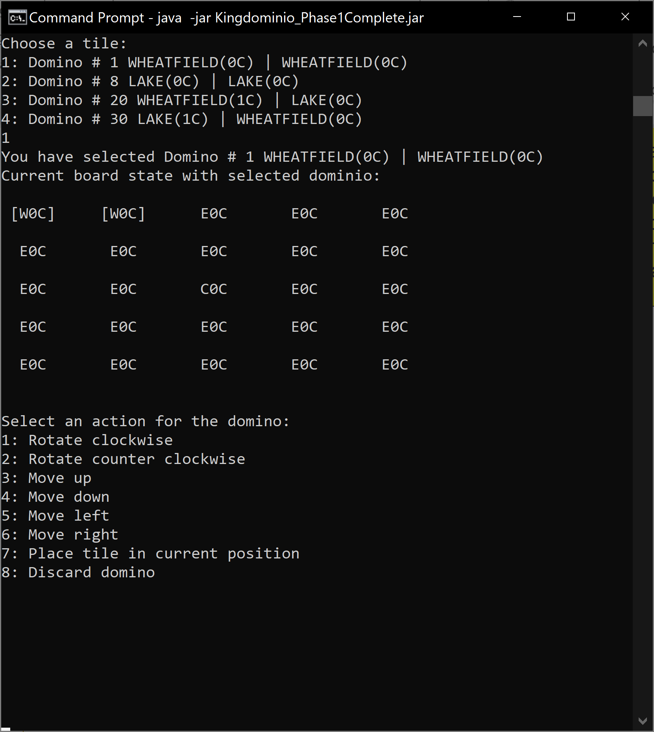

### 5. Domino Placement Menu

|  |  |  |  |  |
| --- | --- | --- | --- | --- |
| Test # 5 | Input/Action | Expected Output | Actual Output | Pass? |
| Test # 5-1 Display | Start program | Menu displays correctly with no errors; after domino is selected and played, play continues to next player, showing domino selection menu prompt | Menu displays correctly with no errors; after domino is selected and played, play continues to next player, showing domino selection menu prompt | Yes |
| Test # 5-2 Rotate clockwise | Type 1, Press Enter | Domino is rotated clockwise in current position; error occurs if rotation would place domino outside of game board; domino board is reprinted showing updated position | Domino is rotated clockwise in current position; error occurs if rotation would place domino outside of game board; domino board is reprinted showing updated position | Yes |

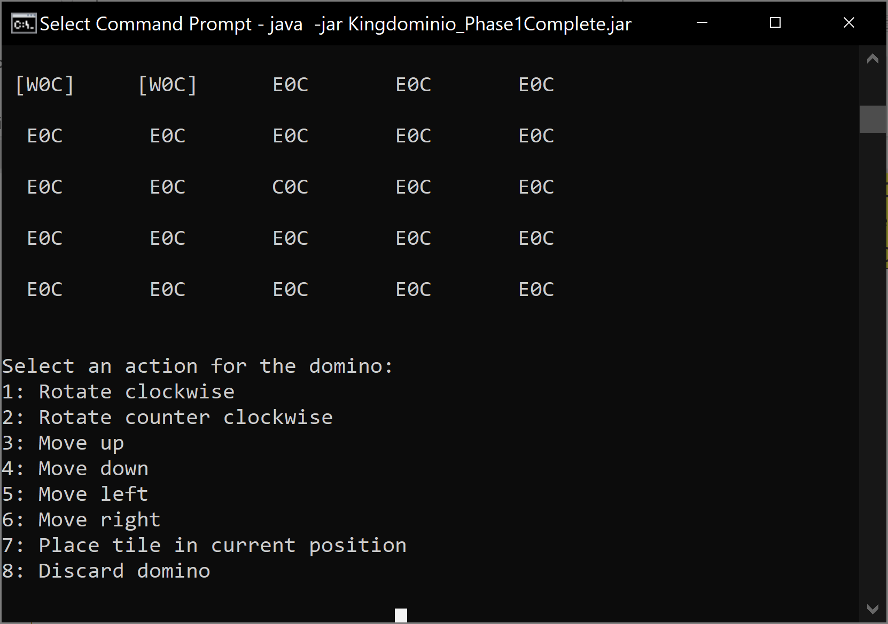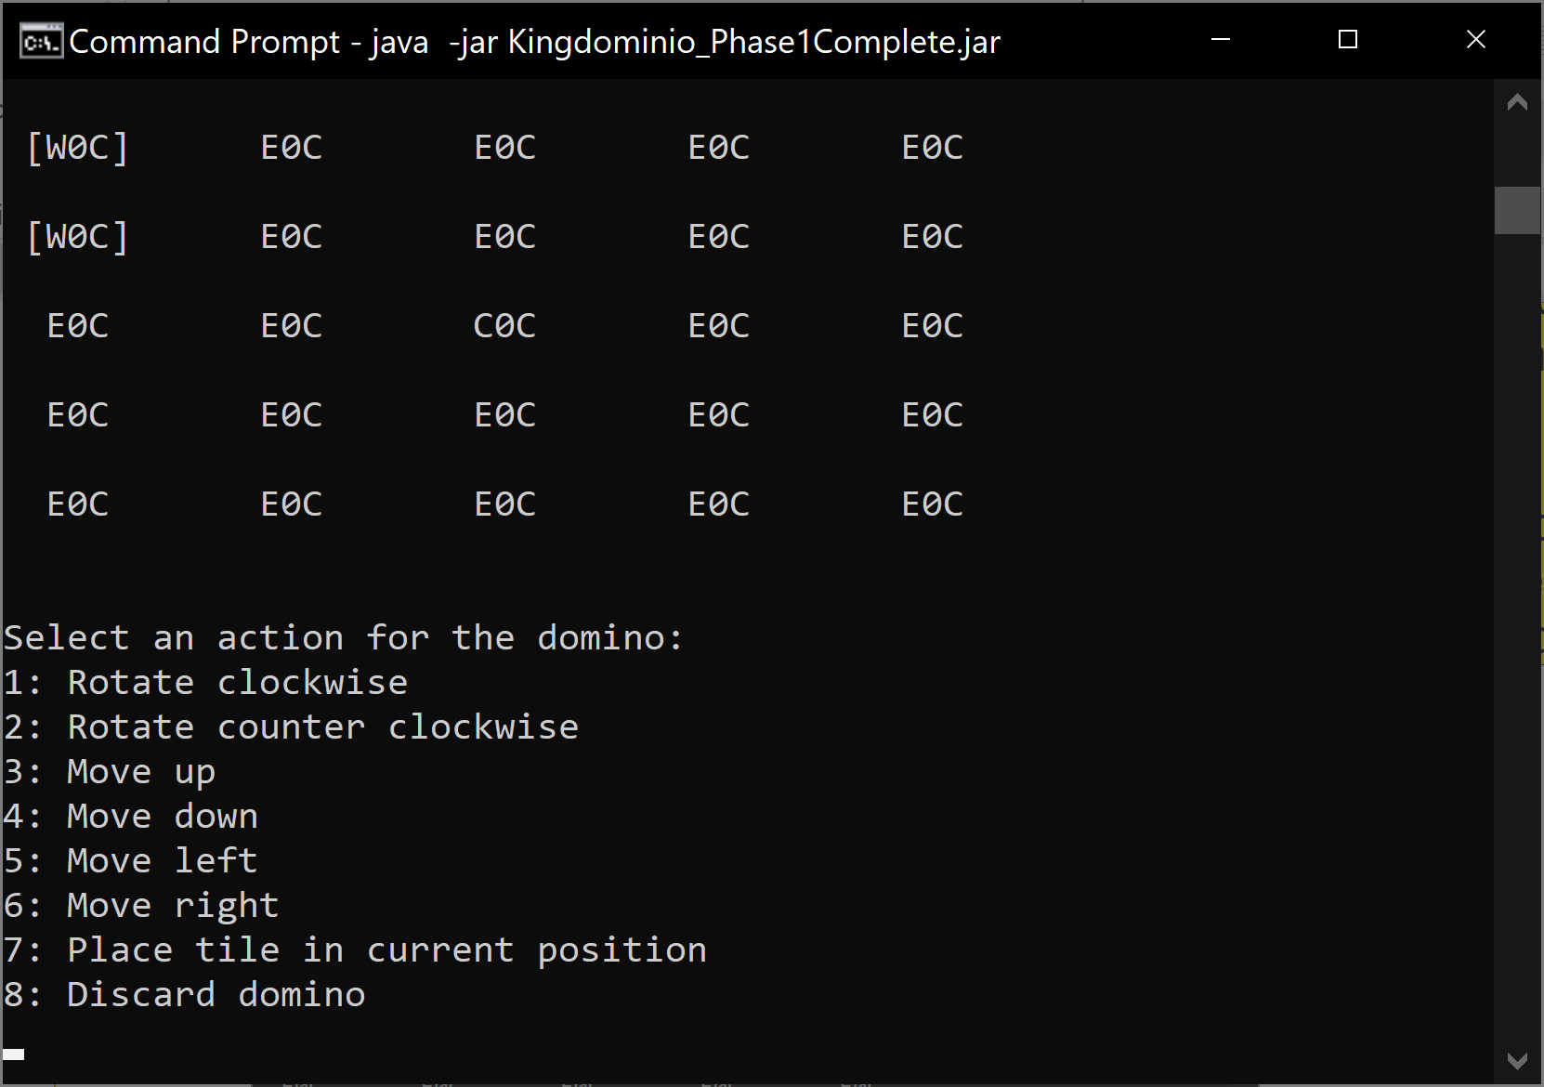

|  |  |  |  |  |
| --- | --- | --- | --- | --- |
| Test # 5-3 Rotate counter clockwise | Type 2, Press Enter | Domino is rotated counter clockwise in current position; error occurs if rotation would place domino outside of game board; domino board is reprinted showing updated position | Domino is rotated counter clockwise in current position; error occurs if rotation would place domino outside of game board; domino board is reprinted showing updated position | Yes |
| Test # 5-4 Move up | Type 3, Press Enter | Domino is moved up from current position; error occurs if move would place domino outside of game board; domino board is reprinted showing updated position | Domino is moved up from current position; error occurs if move would place domino outside of game board; domino board is reprinted showing updated position | Yes |

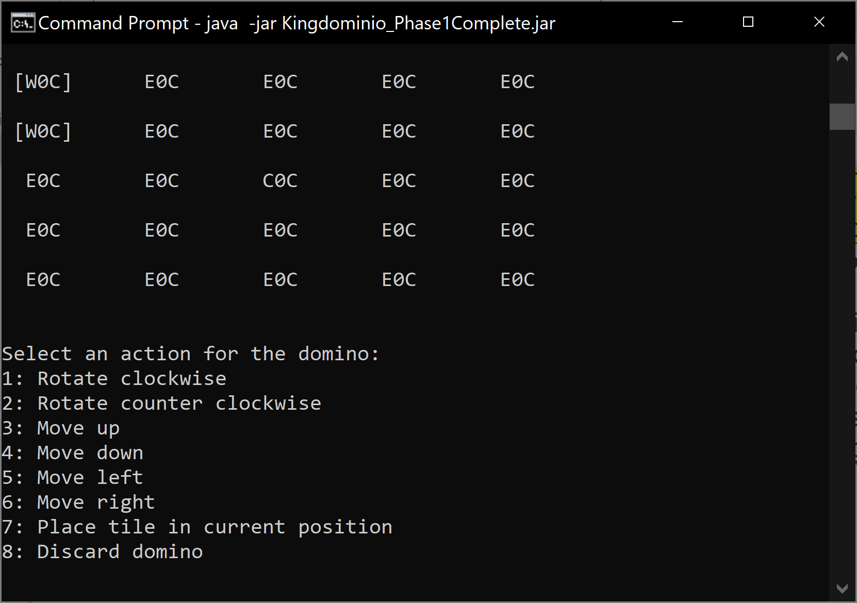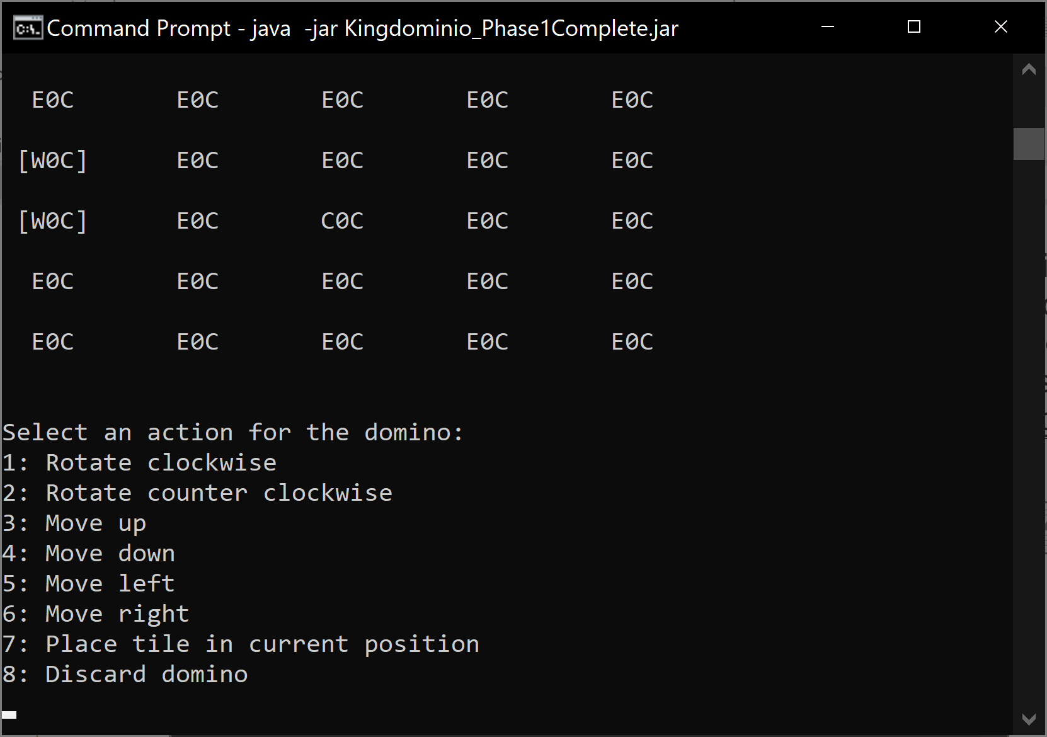

|  |  |  |  |  |
| --- | --- | --- | --- | --- |
| Test # 5-5 Move down | Type 4, Press Enter | Domino is moved down from current position; error occurs if move would place domino outside of game board; domino board is reprinted showing updated position | Domino is moved down from current position; error occurs if move would place domino outside of game board; domino board is reprinted showing updated position | Yes |
| Test # 5-6 Move left | Type 5, Press Enter | Domino is moved left from current position; error occurs if move would place domino outside of game board; domino board is reprinted showing updated position | Domino is moved left from current position; error occurs if move would place domino outside of game board; domino board is reprinted showing updated position | Yes |
| Test # 5-7 Move right | Type 6, Press Enter | Domino is moved right from current position; error occurs if move would place domino outside of game board; domino board is reprinted showing updated position | Domino is moved right from current position; error occurs if move would place domino outside of game board; domino board is reprinted showing updated position | Yes |
| Test # 5-8 Place tile in current position | Type 7, Press Enter | Domino is placed in current position; error occurs if current position is not valid, blocking placement; player board is reprinted showing where domino was placed | Domino is placed in current position; error occurs if current position is not valid, blocking placement; player board is reprinted showing where domino was placed | Yes |
| Test # 5-9 Discard domino | Type 8, Press Enter | Domino is discarded; play continues to next player | Domino is discarded; play continues to next player | Yes |

### 6. End Game

|  |  |  |  |  |
| --- | --- | --- | --- | --- |
| Test # 6 | Input/Action | Expected Output | Actual Output | Pass? |
| Test # 6-1 Display | Play game to completion | Final scores display for each player | Final scores display for each player | Yes |

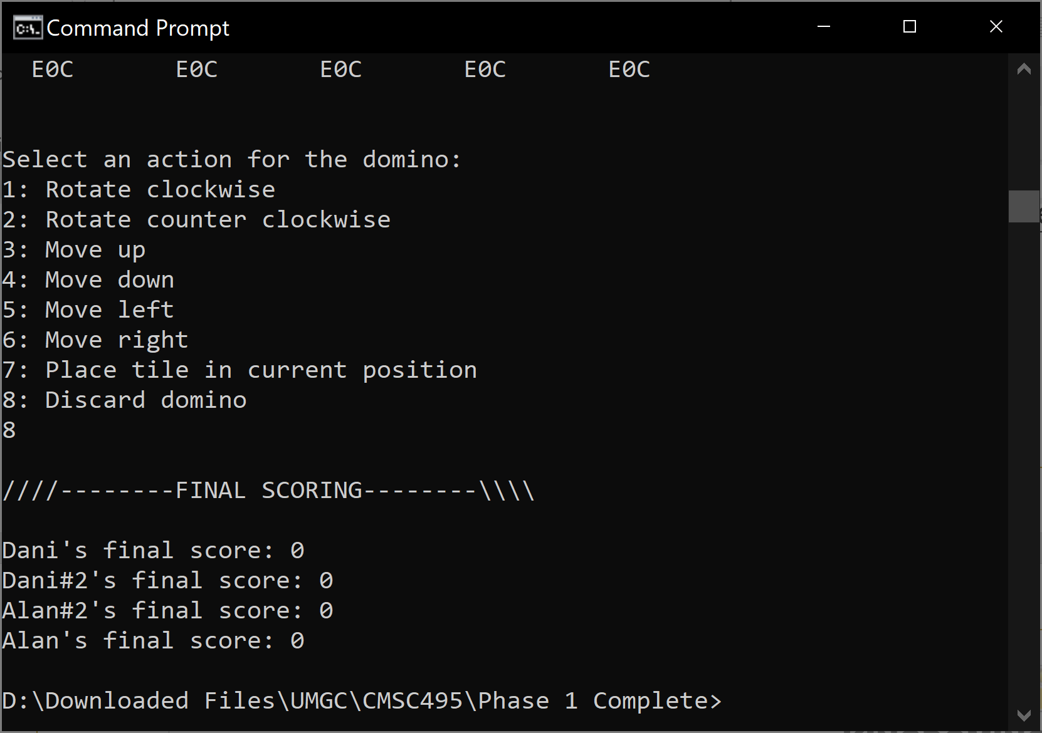



KINGDOMINO

# 7. DESIGN & ALTERNATE DESIGNS

## Introduction

In creating the Java-based design for the Kingdomino digital board game, team Domino Dynasty will focus on a 3-phase approach to ensuring that our project captures the essence of the physical board game. In the first phase, we will design a framework that will drive the gameplay and employ a text-based logic driver that will test the framework to ensure that it functions properly. Next, we will design a Graphical User Interface (GUI) overlay over the framework that will drive the game play. The GUI framework will incorporate much of the logic used in the text-based logic driver, which should reduce the amount of design and development time needed overall. In the last phase, once a working GUI-driven product has been created, we will go through and revise to attempt additional efficiencies and effect a polished final product.

## Purpose

This document's purpose is to produce a working project design model from which our team will build a final product.

## Scope

This document will cover both the base framework and GUI overlay implementations of the product, to include the underlying classes, methods, and dependencies that will drive the program.

## Overall Design Approach

We will employ only Java to run every aspect of the game, from sounds, to animations, and everything in between. We will incorporate modularity, programming structures, efficient algorithms, and object-oriented programming (OOP) design to meet and exceed the project parameters.

## Phase 1: Base Framework Design

### Summary

The intent of designing an underlining framework versus attempting a GUI implementation from the start is to establish a solid foundation of logic in the underlining program that will reduce the amount of work needed in the subsequent development phases. The base framework will contain a complete working model of the Kingdomino board game logic and would be all that is needed to run the game sans a game play logic driver. Each section of the Phase 1 design breakdown will feature a Phase 1 framework class and its dependencies.

### Domino.java

The domino in a game of Kingdomino is the object being manipulated by the player on their player board with the objective of scoring the most points based on its placement. Each domino is unique and uniquely numbered “dominoNumber”, and player order “playerOrder” is determined by the selection of a domino each round. The two-sided domino will need to store information for both sides of the domino “sideA” and “sideB”, and this information will need to be able to be retrieved at will “getSideAxxx()”, and “getSideBxxx()”.

#### Figure 1 – Domino.java class design

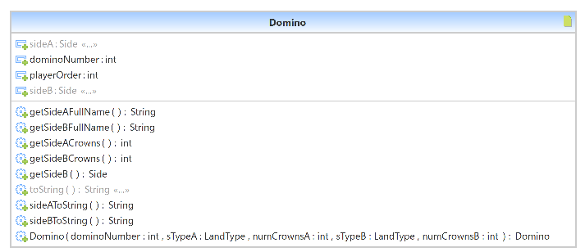

#### Figure 2 – Representation of a domino in Kingdomino



### GameBoard.java

In Kingdomino, the game board retains each player’s played dominos. The player places their 1x1 castle tile, then places 2x1 dominos next to their castle following these rules: (1) the domino placed must be next to the castle space or a face of one of the sides of the domino must match the face of a domino it is being placed next to, and (2) the collective area of the dominos played cannot extend beyond a 5x5 area. The crux of this game will revolve around the domino and the gameboard, as well as the manipulation of the domino around the gameboard area.

#### Figure 3 – GameBoard.java class design

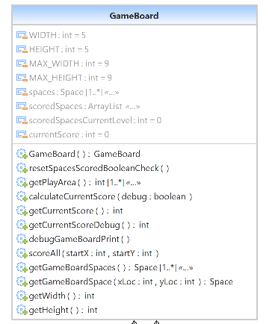

#### Figure 4 – 9x9 Game Board Broken into 5x5 Squares at Each Edge; Point [4,4] Overlap

Because a 5x5 area is the largest play area, we can achieve having a castle being located at any place in the 5x5 area by instead determining a 9x9 initial play area around the castle. This is because putting a castle at the x4, y4 center position of a 9x9 area would put it at the corner edge of any 5x5 drawn at either +-x +-y extremity, making that initial castle position a valid play position or any 5x5 area. The MAX_HEIGHT and MAX_WIDTH parameters will be used to store this information. As the player places dominos, the playable area will be updated through “getPlayableArea()”.

Another important function of the game board is to keep track of the player’s score based on the placement and orientation of dominos on their game board. Score in Kingdomino is determined by the number of matching domino sides touching multiplied by the number of crowns on the face of those domino sides. Thus, if a matching area consists of 6 dominos of the same type and 3 crowns, the total score for that area would be 18 crowns. There may be multiple areas on a single game board that can score points. To capture the groups and scores, each space of the game board will need to store the information of the domino placed there (Space subclass). Then, a function “getCurrentScore()” will recursively traverse through the board, adding areas to an array list of connected graphs and scoring those areas after the entire board has been traversed.

### LandType.java

#### Figure 5 – LandType.java class design

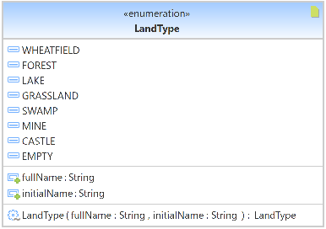

#### Figure 6 – LandType.java class design

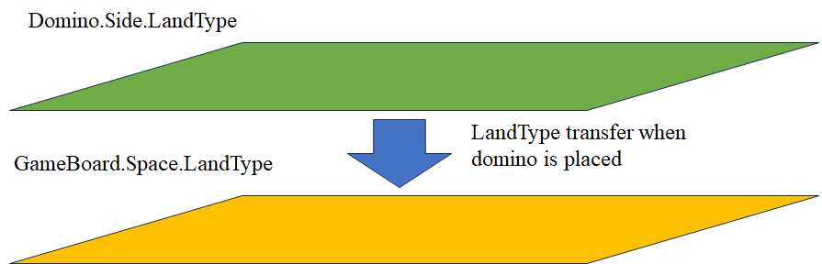

In Kingdomino, there are a set number of land types a domino can possess. Thus, the game board can also only possess those same types since dominos are played on top of the game board. In our design, we ensure that these land types are captured in the enumerated class “LandType”. Dominos will store “LandType” information, one each for both of their sides, and the game board will also store land type information for the domino side that is placed above it.

We will also incorporate a way to read this information as a text string for future functionality when the GUI is implemented (“fullName” and “initialName”). This will allow us to display the information on a Heads-up Display (HUD) near the playboard to assist players.

### Player.java

#### Figure 7 – Player.java class design

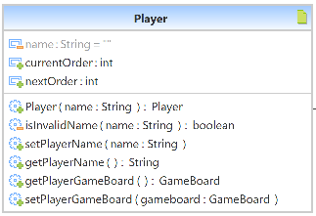

The player class will contain all of the data that represents a player in the game. As such, each player will have a customizable name (playerName) and their own game board. Game play order will be stored in the Player data structure as well.

## 

### ProjectInfo.java

#### Figure 8 – LandType.java class design

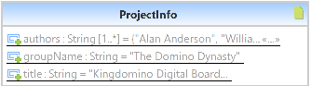

This class only serves to store the project and team information to be readily replicated to other parts of the program.

### StaticGameDominoList.java

#### Figure 9 – StaticGameDominoList.java class design

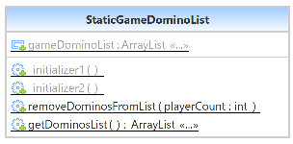

This class will store a list of each type of domino in Kingdomino. When the game starts, this list will be copied so that changes can be made to the copy throughout gameplay. This class will contain methods to retrieve the list [getDominoList()] and remove dominos from the list [removeDominosFromList()].

### TestGameBoardScoring.java

This class will contain methods to randomly generate a player game board and score that board. This will allow the quality control and testing teams to have a tool to test the logic driving a core part of the game.

### TextBasedKingdomino.java

This class is the driver of the logic flow for a game of Kingdomino. This class will accomplish the following:

* Allow players to choose the number of players
* Allow players to enter their player names
* Allow players to select a domino each round
* Allow players to rotate the domino and move it orthogonally around the player board before placing
* Provide end-game scoring after all dominos in the game have been placed

#### Figure 10 – TextBasedKingdomino.java class design

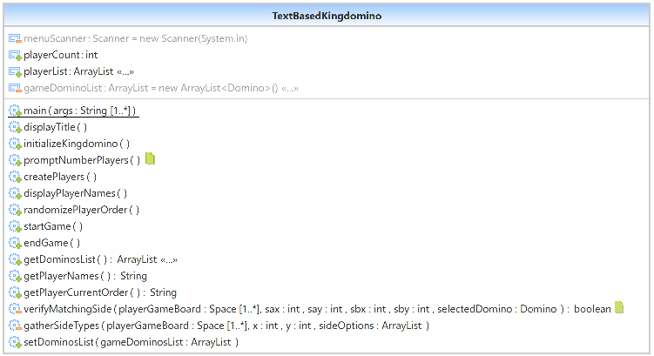

## Phase II: GUI Overlay Design

### Summary

For Phase II of the product design, our team will focus on implementing a GUI overlay over the text-based framework. We believe this to be a better approach over developing the GUI from the start because it will save development time and allow us to have all the necessary logic and functionality of the game already in place before implementing a GUI. As such, much of the focus on design in phase two will be on delivering a fully functional interface.

### General Design Approach

First, we will develop GUI representations of each of the elements in the text-based framework. The logic behind the gameplay will have already been completed, so we will be able to focus our efforts on developing the look and feel of the game. We will start with the more difficult elements which include manifesting the game board and gameplay visuals.

#### Figure 11 – Mock Game Play GUI

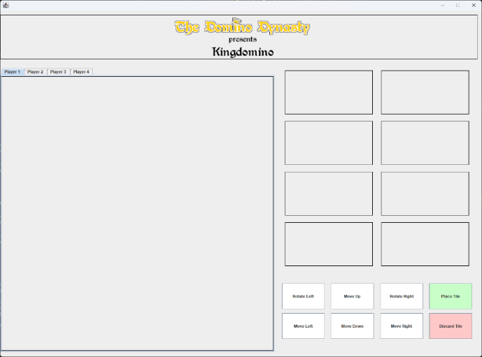

#### Figure 12 – Mock Menu GUI

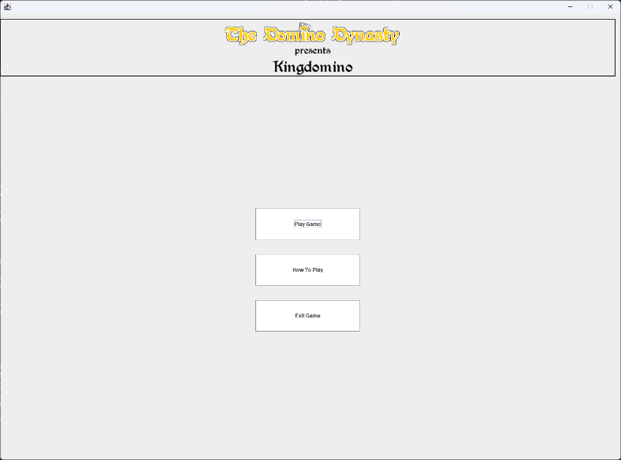

### Finalizing Phase II Design Approach

As we closed out with Phase II, we ended up with roughly 40 plus Java classes that comprised the entirety of the Phase I framework and Phase II GUI Overlay. The GUI Java classes we created for Phase II were designed with the idea that they would simply overlay over the base framework and provide a GUI-based interface for the user while also displaying the game play. Using the mock UI, we created a design that was fairly similar. Instead of seeing two sets of dominos per round, we changed it so that the player would only see one set due to our belief that seeing dominos for the next round was useless in this digital version (we would regret that decision and redesign the UI again in Phase III).

#### Figure 13 – Mock Game Play GUI

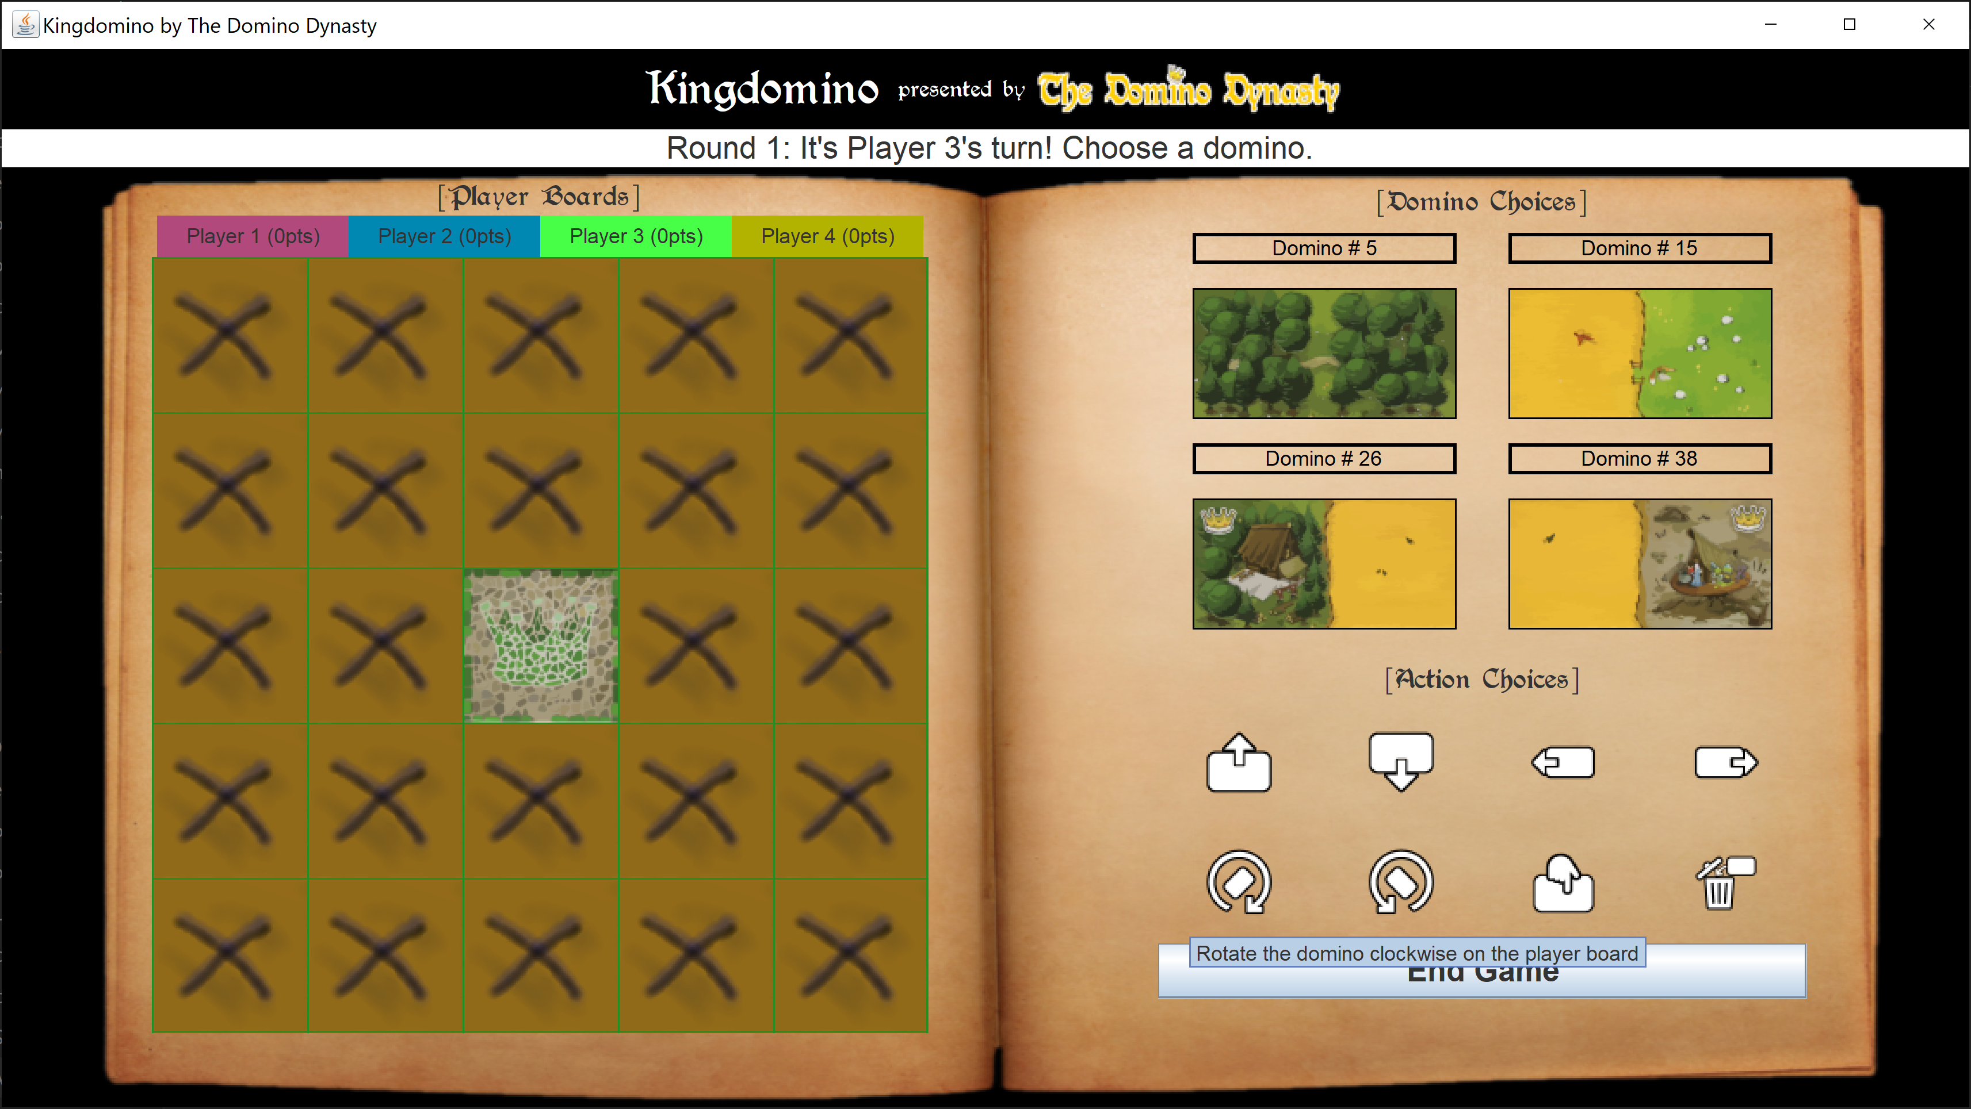

## Phase III: Beautification

### Summary & Design Approach

Understanding that we have a short product development timeline, most of our efforts will go into ensuring that the Kingdomino digital board game functions the same as the physical board game. Our final phase will consist of adding animations and graphics that will give the game a similar look and feel to the original. As such, we have contacted the makers of Kingdomino, Blue Origin Games, to receive permission to use their artwork for our non-commercial project. We felt that this was an important step in ensuring we could deliver a gameplay experience similar to the original. The design approach for the 3rd phase will consist of gathering and making additional graphics and sound assets to round out the overall game play experience.

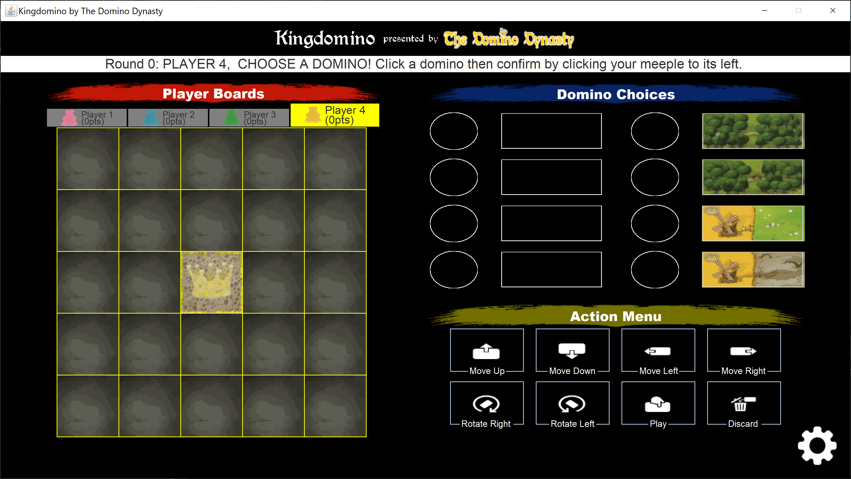

## Alternate Designs

While we did not intend to have alternate designs, below are designs that were either upgraded or discarded as a part of our GUI design process from Phase II into Phase III.

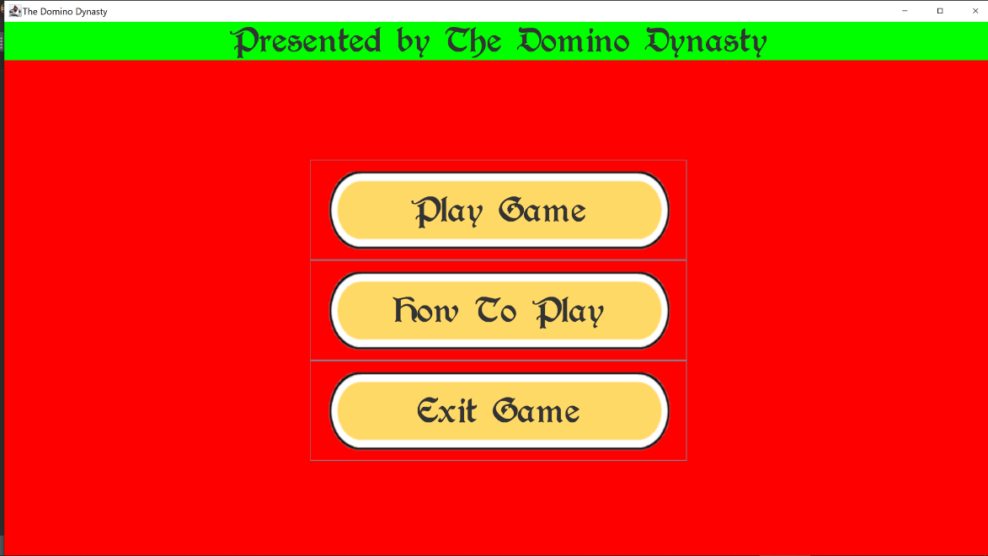

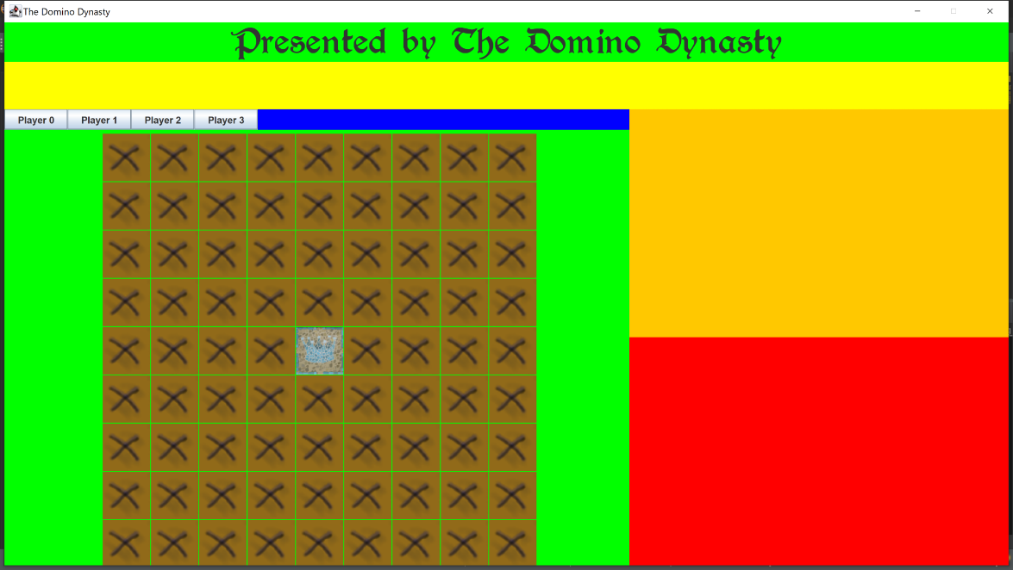

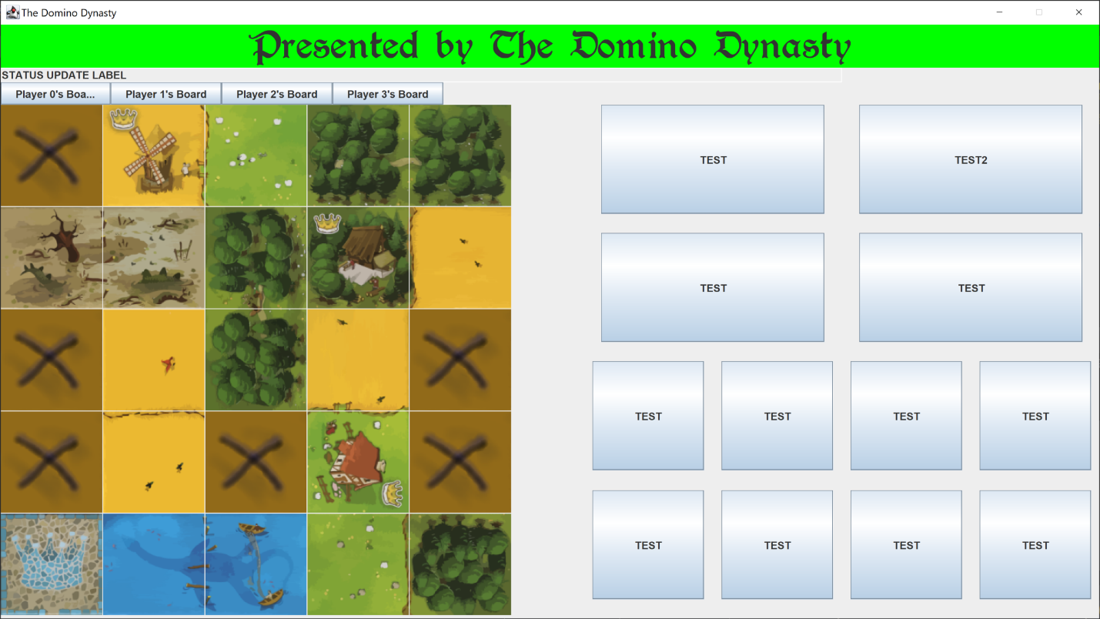

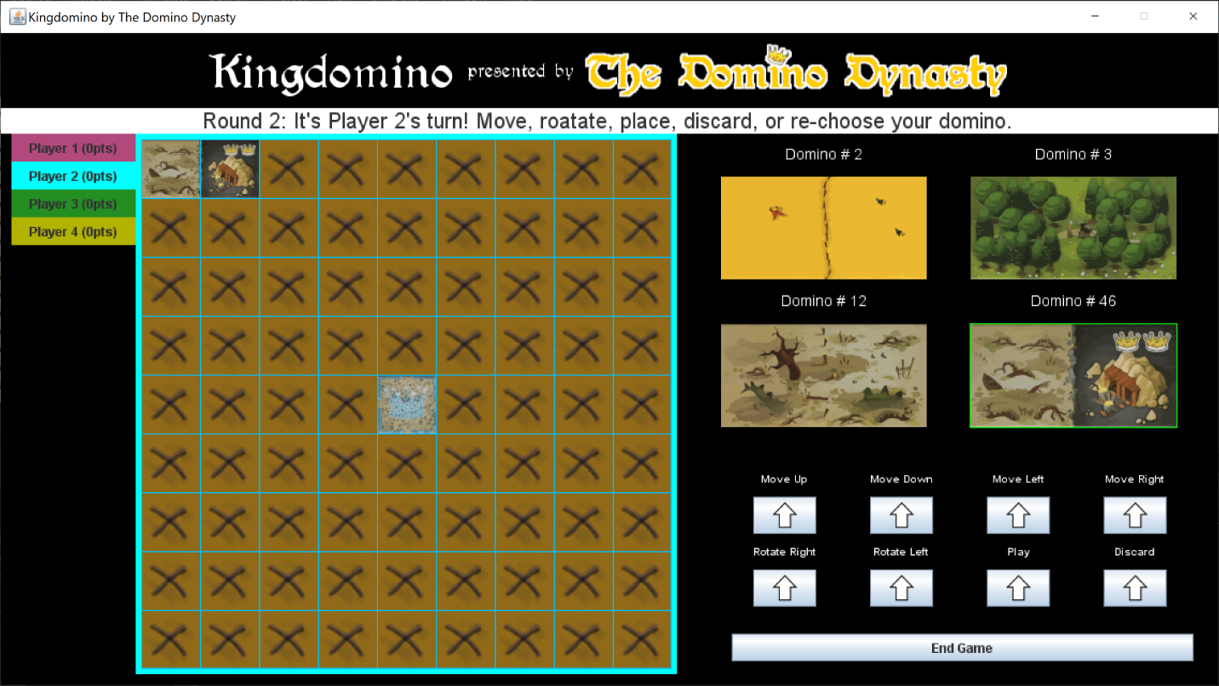

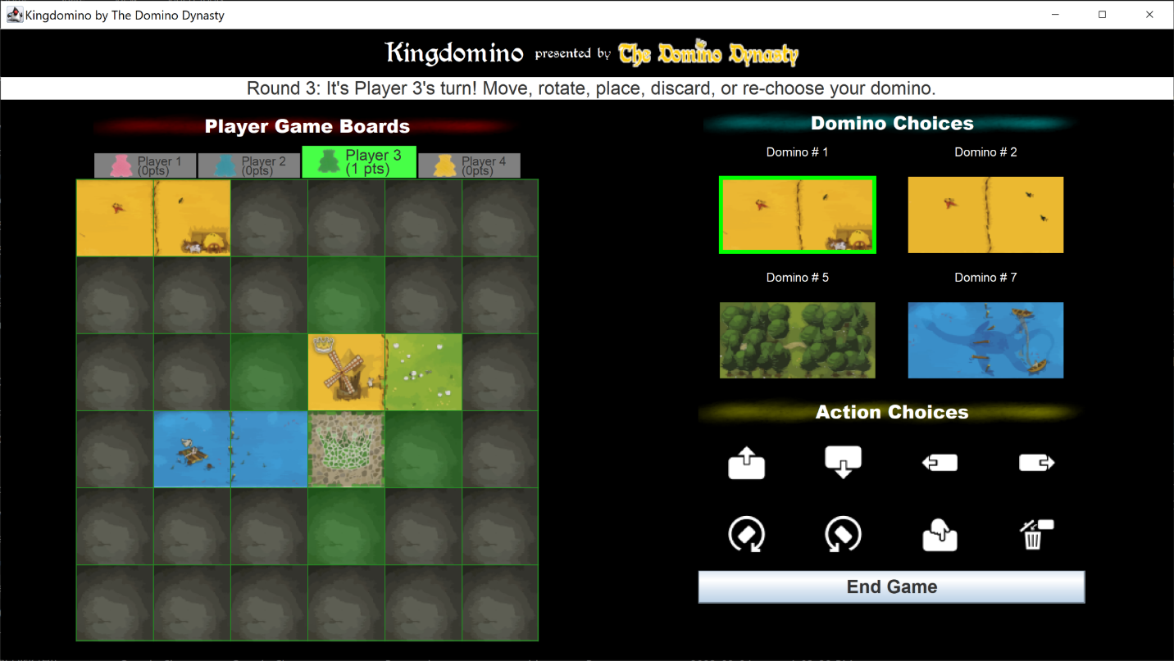

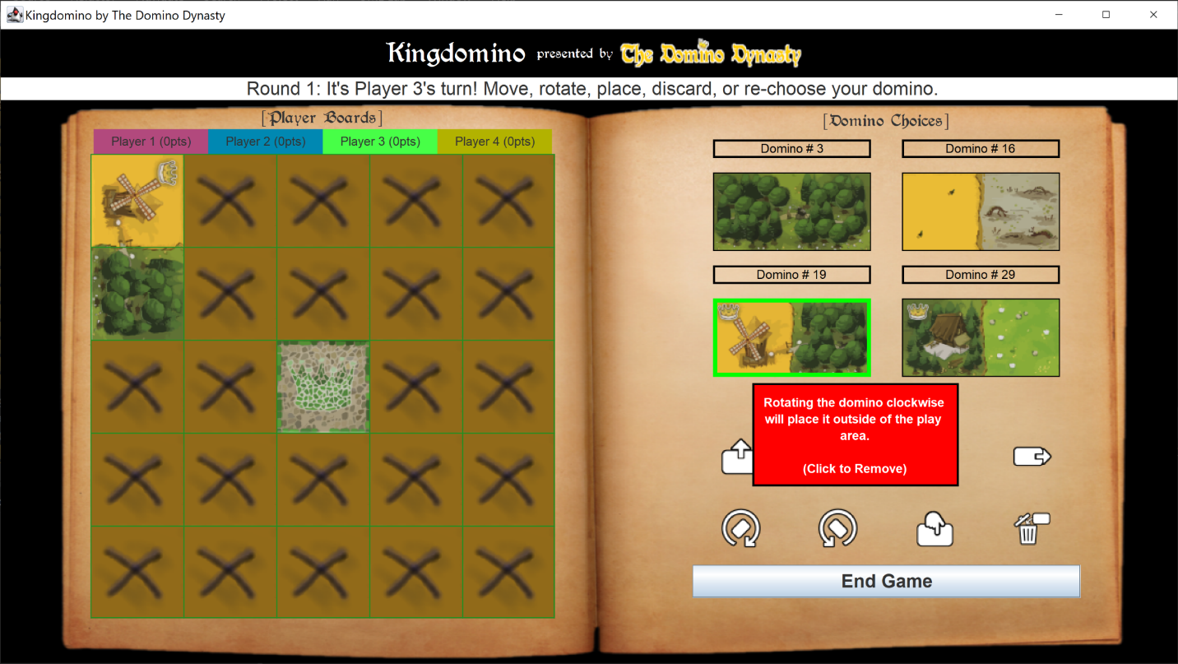

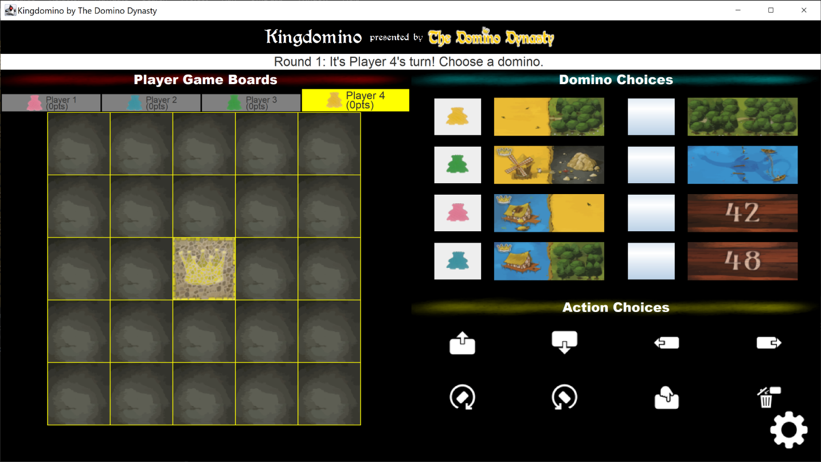



KINGDOMINO

# 8. DEVELOPMENT HISTORY

## Summary

For Phase I, our team focused on getting the framework for the game complete, as we understood that having a solid foundation would make it easier for us in later stages of development. Although we have encountered a few problems along the way, our members’ attention to detail and ability to be flexible have afforded us success at every milestone.

Phase II is where we planned to implement a 2D layer over the text-based foundation that we created in Phase I. We assumed that doing it this way would save us time because all of the game logic is completed, and now we only need to convey it to the user on screen. Ultimately, we feel that we are having a successful Phase II and believe that this will make our Phase III even easier.

Our team planned for Phase III to be short so that we could allocate more time to fixing our documentation. Still, we needed to commit to some of the changes we made in Phase II to our program, while also allowing ourself to be flexible for the new changes we decided to make in Phase III. As with the other phases, our team’s flexibility and dedication allowed us to stay on task and accomplish the goals we set for the application development portion of Phase III.

## Problems Encountered

This section will detail the problems we encountered in each phase.

### Phase I

#### Task List / Schedule

We originally used a task list generator that was tied to our Discord chat group. However, we found that the task list was not very detailed and was not very user friendly. In order to ensure that everyone had a clear picture of the tasks and deadlines, we created an Excel-based task list which was shared through UMGC’s Office 365 application. This allowed us all better collaborative functionality.

#### Github Learning Curve

Github has proved to be a powerful collaboration tool and has likely saved us a lot of time and wasted effort. However, in the beginning, most of us did not have experience with using Github. We had to quickly become knowledgeable on the website and figure out how we would utilize it for our group project. Some important features, like not being able to accidentally wipe out an entire folder of programming files with a single click of a button, are locked behind a paywall. We continue to remain vigilant to avoid any mistakes while we make updates to our project.

#### Different Java Version / IDE / System Configurations

Our team struggled a bit in the beginning with how to share and collaborate since each of us had varying levels of experience with the various Java development applications available. However, we have since found a way to make it work such that each of us can continue using the integrated development environment (IDE) of our choice. Different versions of java and individual system configurations also posed a challenge in the beginning. We had trouble compiling a version of the JAR executable that would run on each of our systems. We identified the problem as incompatible versions of Java and settings in our IDEs; once fixed, this was no longer an issue.

### Phase II

#### Falling Behind Schedule

Admittedly, our team had not had a respectable appreciation for the amount of work it might take to deliver something like a digital board game, and thus we decided to expand our project development phase at the onset, shifting our Phase I start left and expanding all three phases throughout this new extended timeline. Nevertheless, for Phase II, we still found ourselves missing some of the internal task deadlines as we shifted energies and focuses while some areas found themselves lacking adequate support. Still, the team pulled through and ultimately finished all of the tasks required for Phase II of our project.

#### Java Kind of Sucks for Games

We set out with lofty expectations for what our end product would be. Luckily, most of us watched the [Expectations vs. Reality](https://learn.umgc.edu/d2l/le/news/923430/3119878/view?ou=923430) video that was posted earlier in our course. Many of the things that we thought would be simple (image manipulation, playing sounds, stopping sounds, etc.) proved to be even more difficult than we could have imagined. Much of the time developing the 2D framework involved troubleshooting mundane issues that often took more time and research than they may have been worth to fix and include. Ultimately, we came to the conclusion that without installing additional, non-standard libraries, Java just sucks for games in general. We continue to stick with that hypothesis as we embark into Phase III.

#### Managing Java Layouts

We envisioned that our game would implement various types of animations and screens that would carry the option menus and game play itself. While some of the Java layout types area easy to use, others (e.g., GridBagLayout) are more difficult. The difficulty level was further compounded by the fact that we often could not use just one layout manager, but a nesting of layout managers to get the desired look that we wanted. Furthermore, our decision to use an image array to display the game board had to be taken into account for layout managers that employed it due to how it needed to be displayed. If there was a mistake in the configuration of a layout manager at any level, it would throw off all other levels. We found ourselves needing to do a lot of research in order to achieve even small successes with our use of layout managers.

### Phase III

#### Unexpected Bugs

By definition, a bug is some function of a program behaving in an unexpected way, or emergent unexpected behavior as the result of conflicting code. Our team expected to encounter some bugs in our application, with the plan to squash the bugs that were easier to tackle first before moving on to more difficult ones. We were lucky to only have had a few bugs during the development process. However, one of the bugs – a midi volume issue – escaped us, and we had no easy fix for it if we wanted to maintain the current sound system we were using. At some point, we had to decide whether we wanted to continue searching for bug solutions or focus on areas of the program that needed improvement.

## Re-evaluation of Decisions

This portion covers the decisions we re-evaluated for our project.

### Phase I

#### Using Java

Our team felt that Java would be the best language to develop in since it was the language that we each had at least some familiarity with. While we understood that Java generally is not the programming language of choice for developing games, each of us were very interested in taking on the challenge.

#### Building a Text-Based Foundation First

In the beginning, we made the decision to first build a text-based version of the game before building the GUI. Our thinking was that if we built the text-based game, it would contain all the logic and class structure needed to develop a GUI-based version of the game. We felt that the little time lost developing a text-based version first would be made up by the ease at which we would be able to overlay the GUI version of it. We are happy with the progress thus far and are on track to meet our goals for the later phases.

#### 2D vs. 3D

We contemplated building a 3D version of the game in the beginning. However, after considering the amount of time it might take to model objects, deal with programming in 3D space, etc., we decided that we likely would not have the time to develop a 3D game in the time we have for this project. Thus, we set our sights on developing a 2D version instead.

### Phase II

## The Framework is Immutable

We assumed that if we established an excellent framework of classes and methods that could run the entire game as a text-based version, then applying a 2D overlay / extension to those classes would be easy. At the same time, if we were to build off of the base framework, then we also could not change the base framework because this would have cascading effects across our 2D overlay. Therefore, we decided that we would not change any of the base framework; if adjustments needed to be made, we would create a child / extension of the base framework class and apply those adjustments there. For instance, if Player.java did not have a GUIGameBoard attribute, then we could create GUIPlayer.java, an extension of Player.java, that would contain a GUIGameBoard attribute. This proved to be successful for our team throughout tackling Phase II.

#### Developing a Cartoony Design Style

We went back and forth on several types of styles we wanted to present the game with. Should we choose something cartoony? Or should we go with something sleeker and more professional? One of our targets was ensuring that the UI did not look like a typical UI. We wanted to expound on the base Java UI and give the display a more enjoyable feel. Ultimately, we decided to lean into the cartoon style during the middle of Phase II. We knew that our group’s overall inexperience with this type of project preventing us from fully realizing that design approach, but we committed to it nonetheless. We figured it would be okay because Phase III would give us the time needed to “beautify” our design.

#### Using a UI Creator vs. Hand-Coded UI

In the beginning, we attempted to incorporate UI that was made with a UI Creator. This could have ultimately saved a lot of time and heartache as working with Java UI layouts is precarious at best. However, we found that the UI created by an application does it in a way such that the underlying Java code is difficult to read by a human. Understanding that this may complicate our process of implementing these machine-generated UIs, we reverted to coding the UI manually. While this took a bit more time, we found that this made it easier to manipulate the UI and mold it to our specifications.

#### How to Represent the Player’s Game Board

Another decision at the start of Phase II we had to lock in was how would we go about representing the player’s game board. While there were many ways to approach this problem, we reduced it down to two courses of action: the game board would either be a group of game pieces, or the game board would just be an array of images that represent the game pieces. We went with the latter because we thought that we could do more with images if we decided to add in animations for Phase III.

### Phase III

Phase III for our team was a bit easier to develop for than Phase II, and thus we did not encounter as many issues that needed troubleshooting.

#### Revamping the Game Design

When we started developing the framework, we agreed that there were certain game play elements in the original board game that would not translate well into the digital version we were developing. Thus, we collectively decided to shelve those features in favor of a lean adaptation. However, towards the end of Phase II, we realized that the part we had discarded contained much of the fun that might be derived from the gameplay. We had not fully understood until after a large number of playtest sessions. Nevertheless, we were able to swiftly make the changes and develop the game in a way that we thought would better capture the essence of the original board game.

#### Ignore Some Minor Bugs

All throughout our development, we encountered some bugs here and there. However, we encountered the most bugs during Phase III of our development, noting that we had almost 50 Java classes that were interacting with each other. We were able to squash all bugs except for a midi audio volume related one. In order to save time and focus on other important parts of the project, we decided to ignore the audio bug as it only showed itself when trying to change the audio in the in-game settings. Ultimately, we think we made the right choice and we are very proud of the end product.

#### Features on the Chopping Block

Before entering into Phase III, we understood that we would not have much time implementing features that we wanted before we needed to wrap things up and turn the project in. Nevertheless, that did not stop us from adding a number of additional features that we wanted to add to the timeline, only for us to end up not having time for them. By the end of Phase III, we cut at least three features from the project in order to give us more time to focus on other features and the documentation that would be required.



KINGDOMINO

# 9. CONCLUSIONS

## Lessons Learned

### Alan Anderson

While I have led various project development teams when serving in the military and in my current job, the experience I had as project lead for CMSC 495 was uniquely challenging. This was my first time collaborating on anything related to programming, and I appreciated the opportunity my teammates gave me to do so. I was worried at first that we may have bitten off more than we could chew, but my team’s flexibility and dedication to the project was paramount to our ultimate success. I did not learn any new lessons per se, but lessons I have learned previously were reinforced through my experience with this team project. These lessons included: recognizing the strengths and weaknesses of team members, combating scope creep, fostering clear and constant communication, and applying different leadership styles. They are important lessons that I keep at the ready in my “toolbox.”

I believe that we had an excellent design considering the short amount of time we had to develop our project. The framework, sounds, graphics, UI, and documentation were all a result of the excellent collaborative effort put forth by the team. Despite those strengths, we did encounter a few issues that could be considered limitations, such as Java being poor for game development out of the box and our initial unfamiliarity with the collaboration platform Github. Still, there is always room for improvement, and our project could be made better by either incorporating any of the newer Java libraries specifically designed for game development or re-writing the game in a language that would better support this type of digital board game. Nevertheless, the quality of our product with hopefully show the hard work attention to detail that each participating team member provided.

### William Feighner

Reflecting on this group project, I found it to be a highly enriching experience that differed significantly from my prior solo school projects. One of the most impactful aspects was the collaborative nature of the work. This was the first school project where I was relieved of the burden of having to accomplish everything on my own. The distribution of tasks among various team members was a welcome change and allowed me to focus more deeply on specific aspects, thus improving the quality of my contributions. Additionally, the diversity of perspectives within the group enriched our brainstorming sessions, bringing forth innovative ideas and concepts that I would not have conceived on my own. Beyond the collaborative elements, the project also served as an eye-opening introduction to a more structured project life cycle. Unlike my solo coding marathons, this project was broken down into distinct phases, including planning, design, and testing. This structured approach was highly informative, offering me a more rounded understanding of how to successfully bring a project to completion. Overall, the experience has enhanced my appreciation for teamwork and given me valuable insights into project management.

### Michael Wood, Jr.

This course has taught me a lot about the important aspects of developing collaborative projects. One lesson that I had to learn quickly was to expect the unexpected. To me, this means that it is more important to spend time focusing on the things you can control rather than the things you cannot. When our group was assigned an extra group member, I used this lesson to focus on the benefits of having an extra member. The same lesson could be applied when it comes to dealing with an unresponsive group member. Another lesson I learned was the importance of coding etiquette. With this being a group project, everyone had to make valuable additions to the project. This means that anyone could review and make changes to your code at any moment. I had learned this lesson early when I had provided a class file that had no documentation to explain what the code did, the file had ambiguous variable names, and could have easily been separated into separate classes to improved legibility. Without doing those things, the code was illegible to everyone except me.

### Ibadet Mijit

MIA

### Jenna Seipel

There are several lessons I learned from this project such as practical software development experience, effective communication, and design collaboration. The main impact of all these lessons was applying it in a group setting because the majority of the degree pipeline up to this point focused on individual effort. This project offered the most practical application towards simulating what it would be like to create a software project from scratch as a development team. Another lesson learned involved the impacts of communication. During the project, instances occurred where communication had faltered, and issues arose with delegated tasks being completed. Due to most of the group maintaining regular communication, portions of the project were able to be reassigned to ensure they were completed in a timely manner. Additionally, in a group project with people of varying tastes, design can end up being a very opinionated topic. While the design elements were implemented, the individuals adding the modifications would share their updates, allowing others the opportunity to provide feedback or suggestions before being added to the main project. I think this helped create a final product with unanimous support of the group.

### Joseph Lewis

What I have learned from this project is that any project to be effectively successful and unique requires a good collaborative team. In the beginning we all were figuring out who does what and brainstormed ideas on how we would tackle things. In my past classes, I’ve gotten used to doing projects on my own which has its ups and downs, but having this collaboration shows how much streamlining a thing can be especially if you couldn’t figure something out, another team member is there to assist or alleviate that problem. This team’s constant communication and hard work has motivated me and kept me on track when I’ve had some issues with the project or other challenges. The design, and final product of KingDomino, is amazing and I am grateful to track task for due dates and give feedback on the developing functionalities. I hope to learn more and grow in future collaborative environments, and personal projects.

## Design Strengths

One design strength of the project was the decision to recreate a game that was two dimensional with no moving or physics-based aspects. This decision limited scope creep and possible glitches. Another design strength is that we assigned complex tasks to teams instead of a single individual so that we could both mitigate risk of failure and play to the strengths of more than one individual on the team. Github was also integral to our development process as our collaboration platform of choice, and we consider it a design strength because it enabled us to provide seamless updates to our project without having to pass a ton of zip files to each other back and forth. An additional strength in our design is that the game scales to different resolutions and presents the same regardless of text scaling or resolution scaling on any particular display. This fix for resolutions was developed early on in our 2nd phase when we realized the game was displaying differently on each team member’s monitors.

## Limitations

A limitation of our design choices is the pass and play design. While much simpler to implement and there is no game secrecy to maintain, having a device or screen for each player would be more desirable in a long-term, final project. Another limitation was that out-of-the-box Java is a poor platform for what we were trying to develop; a framework like Unity or Godot would have been better, but we lacked the experience to develop the game using those frameworks.

## Suggestions for Future Improvement

We feel that we made the best product that we could, given the time constraints. However, we also know that there is always room for future improvements. One such suggestion for future improvements could be implementing the expansions of the Kingdomino board game such as Queendomino, Age of Giants and/or Origins. The underlying gameplay would be very similar with additional scoring features, strategy and graphics to add. Another suggestion for improvement could be to make the game multiplayer via Peer-To-Peer connection. However, this feature would’ve required us to make client and server files and would have been impractical to implement due to time constraints. A few additional suggestions include incorporating any of the newer Java libraries specifically designed for game development or re-writing the game in a language that would better support this type of digital board game.

Another future improvement might include adding additional animations to the game that respond to certain game play elements (e.g., a cloud of smoke emanating from behind a domino after placing it on a game board). This would enhance the overall look and feel of the game and subsequently the user experience. Including a leader board or score board that records the results of each game could also be an improvement. Including this would increase the re-playability of the game and give the players a chance to view previous games and make adjustments to their play styles. All of these future improvements would work to make a great game even greater.